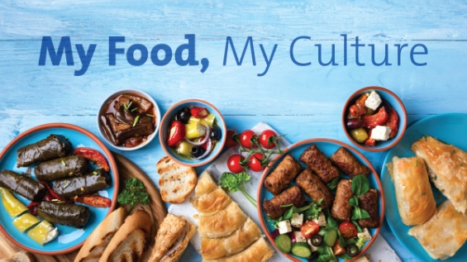
Greek Food Culture
TASK ONE
- What do you know about Greek food?
- Do you know the names of the following popular Greek dishes?

TASK TWO
Match the following ingredients to the following dishes. Some ingredients can be used in more than one dishes:

aubergines
bread
butter
carrots
celery
chopped tomatoes
cinnamon
cornstarch
cucumbers
dill
dried beans
eggs
feta cheese
flour
garlic
green peppers
milk
minced meat
olive oil
olives
onion
orange
pepper
potatoes
rice
salt
spearmint
yoghurt
salt
sugar
tomato juice
tomatoes
vanilla
vinegar

Mousaka | Greek Salad  (Horiatiki) | Bean soup  (Fasolada) | Greek Meatballs | Tzatziki | Rice Pudding  (Risogalo)
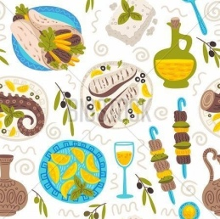



TASK THREE
Read the following article and match its paragraphs to the appropriate headings. The first one has already been done for you and there is ONE EXTRA heading.

Greek Food Culture

1) D. The Heart of Greek Social Life
Greek food is known worldwide for its fresh ingredients, healthy recipes, and great taste. It’s a big part of Greek culture and daily life. Greeks love sharing meals with family and friends, especially during holidays and celebrations. Eating is about more than just food — it’s about enjoying time together.

2)
Traditional Greek meals often include fresh vegetables, olive oil, cheese, bread, and meat or fish. Olive oil is essential and used in salads, cooking, and even desserts. It has been used in Greece for thousands of years. Herbs like oregano, thyme, mint, and basil add lots of flavour.

3)
Mousaka is a well-known baked dish with aubergines, potatoes, minced meat, and a creamy sauce. Souvlaki, grilled meat on a stick, is often served with pita bread and tzatziki — a yogurt, garlic, and cucumber sauce. Greeks also enjoy vegetable dishes like gemista (stuffed tomatoes and peppers) and horiatiki, a classic salad with tomatoes, cucumbers, olives, and feta cheese.

4)
Bread is eaten at almost every meal, and feta cheese is very popular. Mezedes are small dishes, like appetisers, often shared at a taverna. These can include olives, dips, seafood, and fried vegetables.

5)
Greek desserts are sweet and rich. Baklava is made with pastry, nuts, and honey syrup. Loukoumades are small fried dough balls with honey and cinnamon. Other desserts include galaktoboureko (milk custard pie) and spoon sweets made from fruit.

6)
Meals in Greece are relaxed and social. Lunch is usually the biggest meal, and dinner is eaten late. People sit for a long time, eating slowly, talking, and laughing. Sundays and holidays often involve special meals and long family gatherings.

7)
Greek food is about enjoying life, sharing, and celebrating culture. It shows love, tradition, and hospitality. Whether at home or in a restaurant, eating in Greece is always a joyful experience.

A. Signature Flavours on Every Table | E. Small Bites, Big Traditions
B. Rituals Around the Table | F. Sweet Endings with History
C. Food as a Reflection of Culture | G. Flavours of the Mediterranean
D. The Heart of Greek Social Life | H. Essential Ingredients
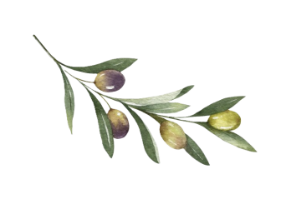
TASK 4
Choose the correct answer for questions 1 – 8:
1. What is the main idea of the text?
a) Greek food is only about healthy eating
b) Greek food is simple and modern
c) Greek food is an important part of culture and social life
d) Greek food is mostly desserts
2. Which ingredient is used the most in Greek cooking?
a) Butter b) Olive oil c) Sugar d) Cream
3. What are mezedes?
a) A type of sweet
b) Small shared dishes like appetizers
c) Main meat dishes
d) Breakfast food
4. When do Greeks usually eat dinner?
a) In the morning
b) At noon
c) In the early afternoon
d) Late in the evening
5. Which of these is a sweet Greek dessert?
a) Loukoumades b) Souvlaki c) Horiatiki d) Mezedes
6. What is a taverna?
a) A home kitchen
b) A small Greek restaurant
c) A type of cheese
d) A market
7. Which ingredient is NOT usually in horiatiki salad?
a) Tomatoes
b) Cucumbers
c) Feta cheese
d) Carrots
8. What do Greeks usually do during meals?
a) Watch TV quietly
b) Eat quickly and leave
c) Talk and enjoy time together
d) Eat alone
TASK FIVE
Match each word from the first column with its correct meaning in the second column. Write the letter of the correct meaning next to the word.

1. tradition | a. a small dish eaten before the main meal
2. essential | b. a custom or habit passed down through generations
3. celebration | c. the way something tastes
4. flavour | d. a happy event or party to mark something special
5. hospitality | e. necessary
6. joyful | f. a group of people meeting together
7. appetiser | g. being kind and welcoming to guests
8. gathering | h. happy, cheerful

TASK 6
Complete the sentences by changing the form of the word in capital letters to fit the sentence correctly.

1. We had a long and _________________ lunch with family. RELAX
2. The dish has a very rich and __________________ sauce. CREAM
3. Feta is a very __________________ kind of cheese in Greece. TRADITION
4. Greeks show great __________________ to guests. HOSPITABLE
5. Mousaka is a dish that is _________________ baked. USUAL
6. I love the different _________________ in Greek cooking. TASTE
7. We went to a big family _________________ on Sunday. CELEBRATE

TASK SEVEN
In groups, create your own Greek “taverna” (restaurant). You need to do the following:
1. Choose a name for your taverna.

2. Prepare a menu with:
- 2 starters (mezedes/appetizers)
- 2 main dishes
- 1 or 2 desserts
3. Write a short dialogue or role play between a waiter and a customer. The conversation can include:
- Greetings and introductions
- Asking for the menu
- Asking about ingredients
- Ordering food
- Complimenting or reacting to the meal

