Microplastics
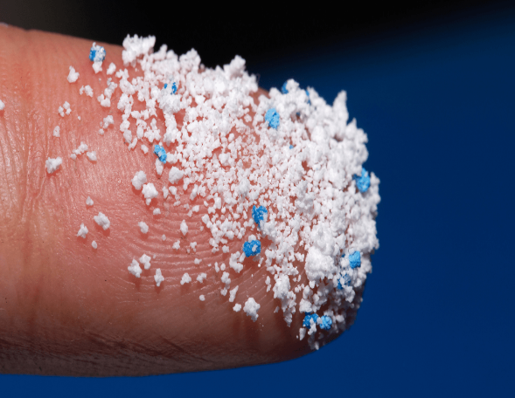
What they are: Most plastics in the ocean break up into very small particles. These small plastic bits are called "microplastics." Other plastics are intentionally designed to be small. They're called microbeads and are used in many health and beauty products. They pass unchanged through waterways into the ocean and pollute it.

Ways to prevent them from entering our house:
- Buy organic clothes (or those made from organic materials)
- Change how you do laundry.
- Buy plastic-free cosmetics.
- Reduce shellfish consumption.
- Use public or alternative transportation.
- Don't microwave your food in plastic.
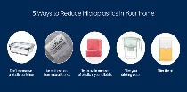
- Regularly dust and vacuum.

