Study the theory and try to do the exercise below.
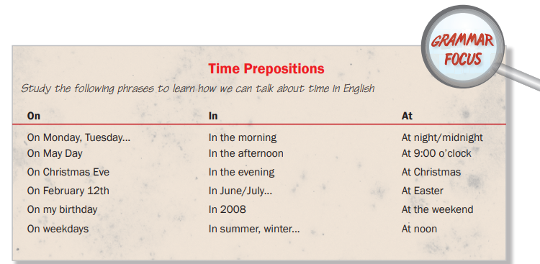
- Lucy is arriving ____ February 13th ____ 8 o'clock ____ the morning.
- The weather is often terrible in London _____ January.
- Take a taxi if you are out alone _____ night.
- She got married _____ September.
- They usually go to the south of France _____ summer.
- Columbus discovered America _____ 1492.
7. His birthday is _____ June.
8. I usually go to my parents' house _____ Christmas. We eat together _____ Christmas Day and give each other presents.
9. The train leaves ______ 8 pm ______ the evening.
10. I love going skiing ______ winter.
11. We met at the restaurant ______ 8 pm.
12. The class is ____ 9 am ______ Monday mornings.
13. I like drinking coffee ______ the morning and tea ______ the afternoon.
14. We went out for lunch _____ noon yesterday.
15. She left London _____ March 4th.
16. I had a party _____ my birthday.
17. Lucy went to New York ______ New Year’s Day.
18. I don’t usually go out with friends ______ weekdays but we often go to the cinema ______ the weekend.
19. I am always in my bed ______ midnight. I go to bed early.
20. ______ Easter we dye eggs red and we make Easter cookies.

