Past Simple vs Present Perfect

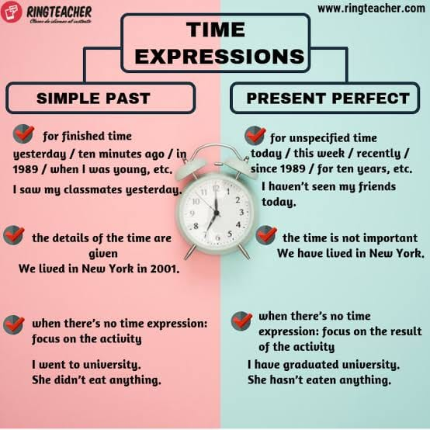

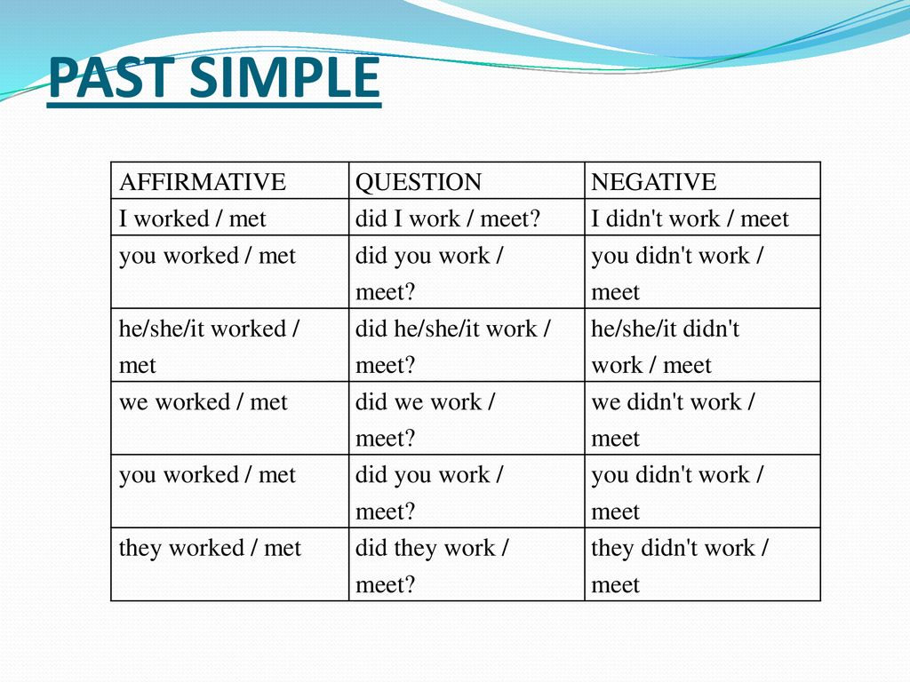

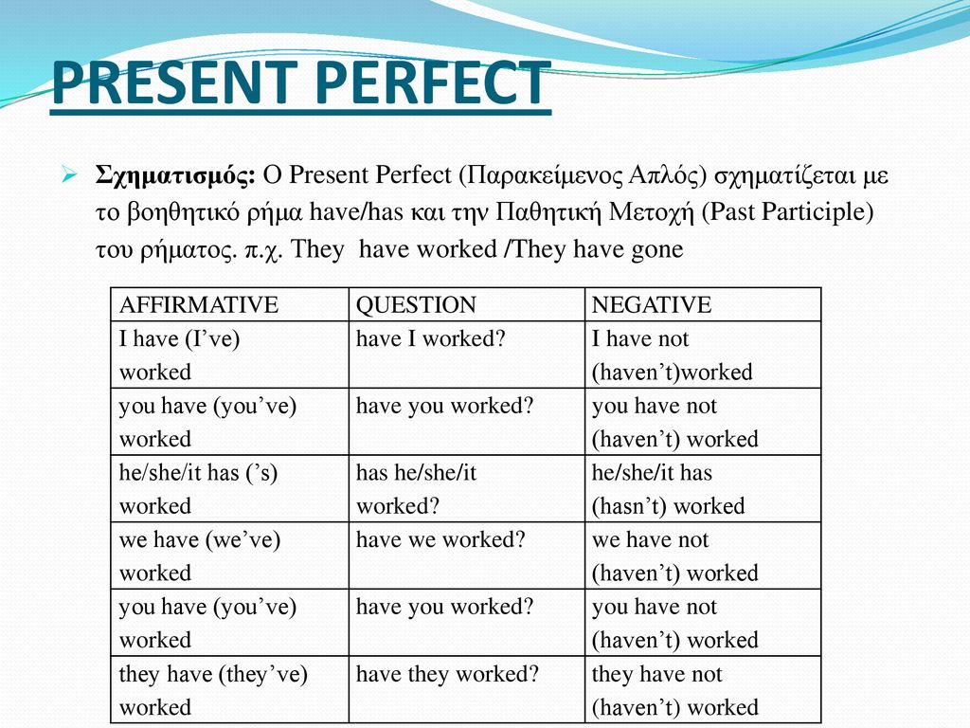

**Time expressions of Past Simple and Present Perfect Simple**

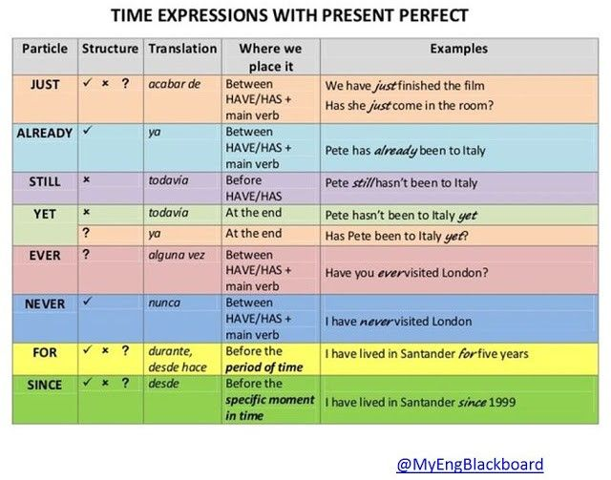

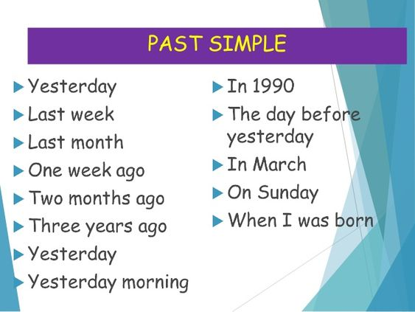

Examples:

1. I have been to New York recently. (I don’t know when exactly)
2. I went to New York last summer. It was amazing. (I know exactly when)