**SAFETY PRECAUTIONS**

1. When working with moving machinery:
   * Tie long hair or wear a shop cap.
   * Always remove your watch, rings and other pieces of jewellery.
   * Roll your sleeves up and fasten all buttons.
   * Remove coats, sweaters and jackets. Otherwise, they may be caught in the machine causing serious accidents.
2. Wear special protective clothes (overall or apron) when working with machine tools or in the foundry, and when forging, brazing or welding.
3. Wear safety glasses or goggles when gas brazing or welding, or when there is a danger of flying chips.
4. Always wear a face shield during electric brazing or welding. The arc can burn your eyes severely.
5. Wear hand protection (special gloves) when hammering or welding and when using grinders or impact wrenches.
6. Wear breathing protection (mask) as a precautionary measure against fine dust from dry sanding when gas brazing or welding and also when working in the foundry.
7. Prefer cadmium-free brazing fillers. Cadmium fumes are very poisonous. Never inhale them.
8. Always use the spark lighter to light the torch when gas soldering, brazing or welding. Never use a match.
9. Never use oxygen when testing for leaks. Use a non-flammable gas*.
10. Keep the blades closed when cutters or snips are not being used.
11. Never carry sharp or pointed tools in your pocket.
12. Always carry tools with their points or sharp edges pointing down or wrapped.

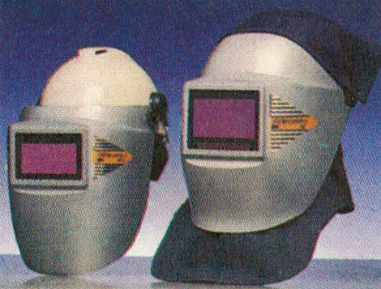

*Head / face shields*

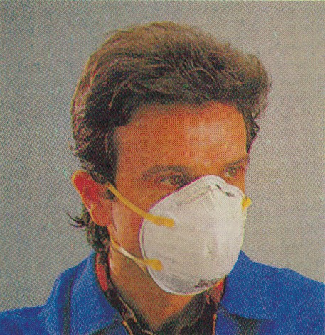

*Mask*

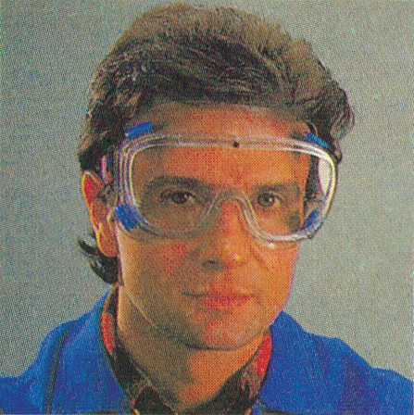

*Safety glasses*

* Any oil in contact with oxygen under pressure may form an explosive mixture.

1. Before using a power tool, check the cord, connections, plug and switch to be sure they are in good condition.
2. Use only suitable bits to your power tools and lock them properly before turning the power on.
3. Always ground portable electric hand tools.
4. When working with electrically powered

tools:

* + Don’t stand on a wet spot.
  + Don’t touch plumbing or other grounded objects.
  + Be sure your hands are dry.

*Plastic mat*

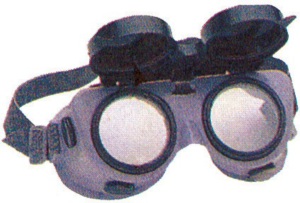 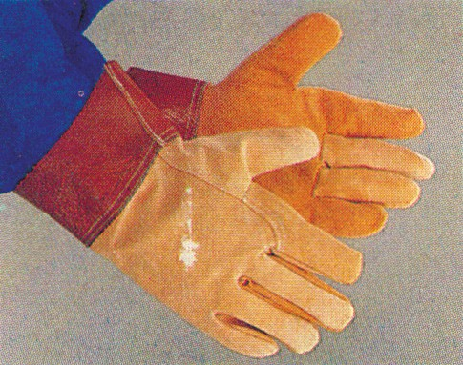 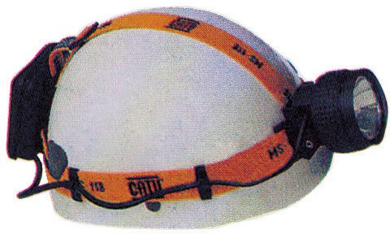

*Goggles Gloves Helmet*

**EXERCISES**

# Classify the safety precautions according to what they refer to.

* 1. Hand tools: **e.g.** *Instruction numbers: 10,*
  2. Proper appearance in the machine shop:
  3. Power tools:
  4. Protective clothing and accessories:
  5. Joining metals with a heat source:

1. **Classify the instructions according to what their omission may result in.**

**Fatal accident**

**e.g.** *10*

**Serious injury**

*10*

**Minor accident**

1. **Make meaningful sentences by joining their parts.**

**A**

1. A non-flammable gas should be used
2. When using electric hand tools, you risk being electrocuted
3. Your feet may be injured
4. Loose clothing may be caught in moving machinery,
5. You risk cuts and scratches
6. To carry pointed or sharp tools safely,
7. To protect your clothing,
8. Falls may occur
9. It is advisable
10. You shouldn’t be engaged in any work activity

**B**

* 1. you’d better wrap their points, blades and cutting edges, first.
  2. so fasten all your buttons.
  3. always wear overalls or aprons when working with metal.
  4. if your hands are wet.
  5. to wear a mask when gas brazing or welding.
  6. if you wear lightweight shoes in the workshop.
  7. if you don’t have the necessary knowledge or expertise to carry it out.
  8. when you carry sharp tools in your pockets.
  9. if there is oil or grease on the floor of the machine shop.
  10. when testing for leaks.

# Say during which work activities you run the risk of:

* 1. an injury in the eyes: **e.g.** *while hammering*
  2. scratches and cuts:
  3. being electrocuted:
  4. being caught in moving machinery:
  5. sustaining a burn:

# Classify the safety equipment used by metal workers under the following categories:

* 1. head (long hair, eye and face) protection:
  2. hand protection:
  3. breathing protection:
  4. clothing protection:

# Match the following with words or phrases:

1. **In the introductory paragraph**
   1. to take place; happen:
   2. lack of knowledge:
   3. written account of facts, events, etc:
   4. less important:
   5. right; correct; suitable:
   6. to ensure; to make certain / safe / reliable:
   7. condition of having good health, comfortable living and working conditions:
   8. to take part; undertake; get involved into:
   9. expert knowledge and skill:
   10. tidy; well arranged; in good order:

# In the «Safety precautions»

* 1. protective device for the head or face:
  2. to put round, cover, fold as a covering for protection:
  3. to breath in; to take something, e.g. air, into your lungs:
  4. material or substance that catches fire and burns easily:
  5. a risk; something that can be dangerous; the possibility of an accident or other undesirable results:
  6. sudden, violent burst of energy (e.g. caused by a bomb or burning gases), which is usually accompanied by a very loud noise:
  7. to connect an electric apparatus, tool, etc, with the ground (to earth it) as a safety precaution against electric shock:
  8. the pipes, water tanks, etc. in a building:

1. **Drawing information from the «Safety Precautions» make sentences beginning with:** • It is a safe practice to...

* It isn’t safe to...
* It is dangerous to...

***Examples***

*It’s a safe practice to remove your watch when working with moving machinery. It isn’t safe to stand in a wet spot while using electric powered tools.*

*It is dangerous to carry sharp tools in your pocket.*

# Fill in the gaps with the suitable preposition. Choose from the list.

in on with up to of into from as

1. For many years SHAFF has supplied its customers drafting media of excellent quality.
2. Hundreds of workers have been engaged the construction of the new highway.
3. Most metals are extracted earth an ore. They are classified two major categories: the ferrous and the non-ferrous metals.
4. Drawing instruments were still made wood thirty years ago.