
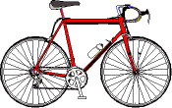
FIND THE WORDS AND THE MYSTERY MESSAGE :WOULD YOU …..
3
4
9
23
2
10
1

2
6
5
7
8
10
11
1
12
14
15
16
17
18
199
20
23
22
24
?

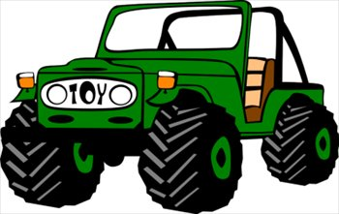
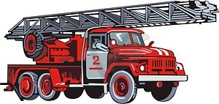

7
15

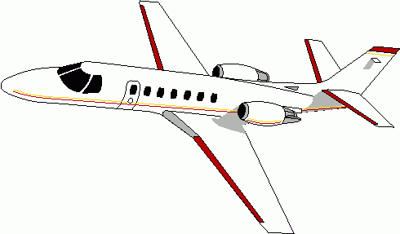


11
16

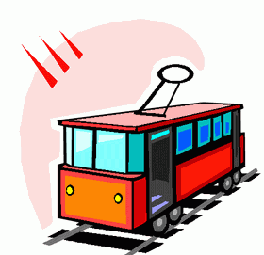

21



24
14
19
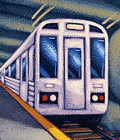
13
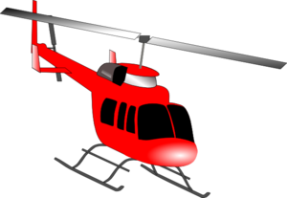

6
17

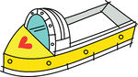

13
12
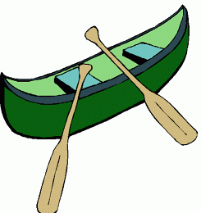


20




21
9
22


18
3


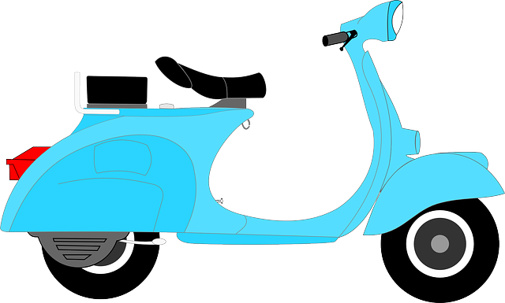
4
8
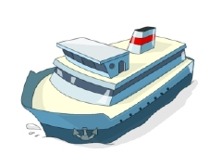
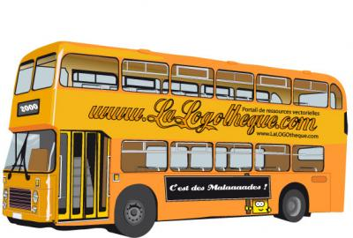
1
5
FIND THE WORDS AND THE MYSTERY MESSAGE :WOULD YOU …..
R
C
A
M
B
U
T
R
A
I
3
C
A
O
C
4
E
R
R
Y
F
R
E
H
G
I
N
E
9
O
T
E
R
C
B
O
L
I
A
S
O
Y
P
R
L
A
N
E
L
I
F
E
B
O
A
A
N
C
E
E
P
J
O
T
O
R
U
T
BA
A
R
I
A
Y
A
T
S
E
J
R
A
M

E
R
1
N
A
V
U
I
S
L
A
N
N
N
E
A
T
R
B
L
C
H
K
I
A
R
C
I
K
E
B
N
C
2
6
5
C
O
P
T
7
S
8
A
R
R
10
11
1
I
T
12
14
15
16
C
K
17
18
T
199
20
T
21
R
E
O
L
M
23
22
24
U
D
E
I
L
E
H
I
F
I
E
K
T
O
H
L
O
O
N
E
R
G
R
O
U
N
D
13
O
E

