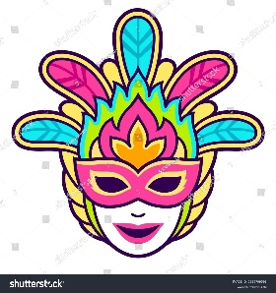

Carnival- Greek Customs

Questions
What’s the name of this custom?
Where does it take place and when?
What do people usually do? (write a few things about what happens)
What does this custom symbolize?
Any other points/comments you want to make

Note: Don’t forget to add a picture or two and write your name and class at the end of the text

