Looks, sounds, tastes, smells, feels

**A.** Complete the sentences about the photos with the words in the box.

awful cold burnt nice relaxing smooth angry interesting bitter good

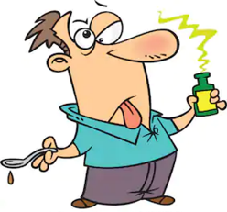

1

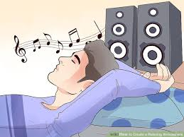

4

3

5

2

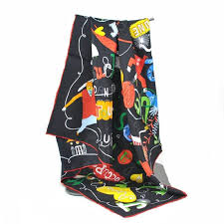

6

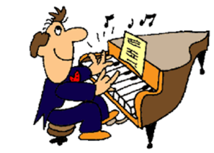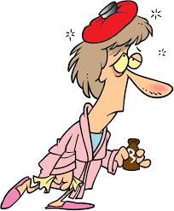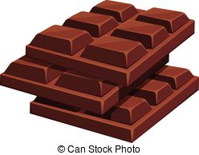

10

9

8

7

1. The medicine tastes ____________. 6. The silk scarf feels ____________.

2. The burger smells _____________. 7. Her perfume smells ___________.

3. He looks ____________. 8. The dark chocolate tastes ___________.

4. The music sounds _________. 9. She feels _____________.

5. The Star Wars looks __________. 10. He sounds ___________.

**B.** Put the correct sense verbs (**taste, feel, sound, look and smell**) into the blanks.

1. My mum is making some cookies. They ___________ delicious.

2. Listen to the music coming from next door! He __________ beautiful.

3. My father was shouting on the phone. He __________ angry.

4. Tonight the food ___________ disgusting.

5. Have you bought a new shirt? It ___________ good on you.

6. The jumper ____________ soft when I touch it.

7. Peter has been working for long hours. He ___________ tired.

8. Sally usually __________ nervous before the exam.

9. What you’ve just said ____________ interesting. I like the idea.

10. I like milk chocolate. It _________ delightful.

11. The soup _________ nice. You must give me the recipe.

12. Jane has passed the exam. She _________ happy.

13. My mum plants roses every year in the garden. They ___________ beautiful.

Key

A

1. awful 2. Burnt 3. Angry 4. Relaxing 5. Interesting 6. Smooth 7. Nice 8. Bitter 9. Sick 10. Good

B.

1. smell 2 sounds 3 looks 4. Tastes 5. looks 6. feels 7. looks 8. feels 9. sounds 10. tastes 11. Tastes 12. feels 13. smell