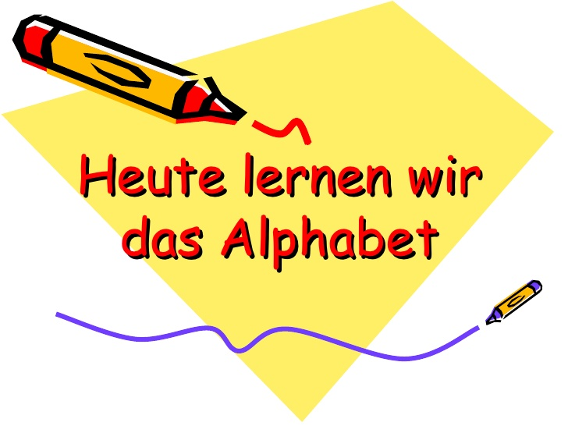

A – B – C – D – E – F – G – H – I
[a] [be] [ce] [de] [e] [ef] [ge] [ha] [i]
J – K – L – M – N – O – P – Q
[jot] [ka] [el] [em] [en] [o] [p] [qu]
R – S – T – U – V - W – X – Y– Z
[er] [es] [t] [u] [vau] [we] [ix] [ypsilon] [zet]
Ä – Ö – Ü – β
[a-Umlaut] [o-Umlaut] [u-Umlaut] [eszet]
HILFE !!! https://www.youtube.com/watch?v=BeP9xghqJao
Buchstabieren Sie bitte
Πες ένα ένα τα γράμματα!

01.) Baby → B – a – b – y
02.) ich → i – c – h
03.) Telefonnummer → T – e – l – e – f – o – n – n – u – m – m – e – r
04.) kaputt → k – a – p – u – t – t
05.) Familie → F – a – m – i – l – i – e

