Fill in the blanks with the correct form of the adjectives in brackets:

1. Brad is by far _________________________ (attractive) boy in town.
2. My friends arrived _______________________ (early) we expected.
3. My dad is _________________________(hard-working) person that I know.
4. Who is ______________________ (rich) man in the world?

5.Travelling by plane is ___________________ (fast) and __________________(safe) travelling by train.
6. Jennifer Aniston is ________________________ (good-looking) Angelina Jolie.
7. His mother is much _______________________ (old) I thought.
8. Ben is ______________________ (bad) golfer in the world.
9. Tom is _____________________ (short) and __________________(fat) his brother.
10. His new novel is __________________________ (exciting) his previous one.
11. London is _________________ (far) Paris, but Moscow is _______________ (far)
12. Do you think that money is ___________________________ (important) love?
13. In my opinion, John is one of ____________________ (lucky) men in the world.
14. These Maths exercises are ________________________ (difficult) yours.
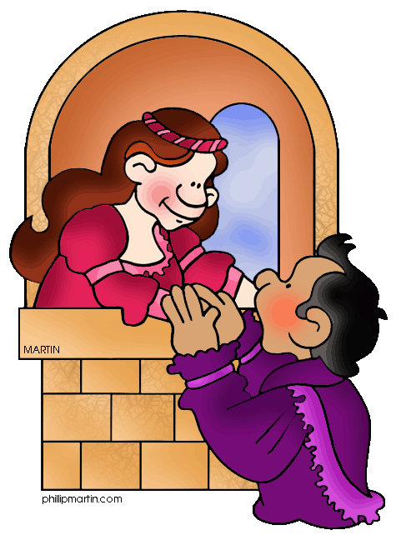
15. ‘Romeo and Juliet’ is ___________________ (romantic) play we have ever read.
16. Your sister is ______________________ (young) in your family.
17. I am ___________________ (bad) at Geography than my sister, but I am _______________ (good) at History.
18. He thinks that Italian food is ______________________(delicious) Spanish food.
19. Helen’s clothes are ___________________________ (fashionable) Susan’s.
20. Sam’s grandmother is ______________________(helpful) person I’ve ever met.
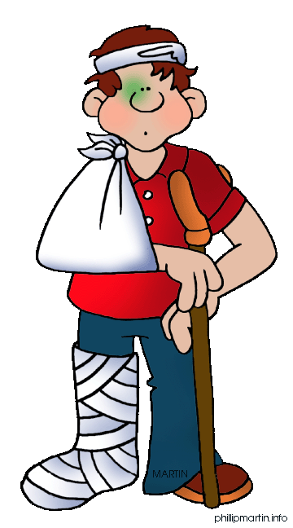
21. August has been ______________________ (hot) month this year.
22. Which is ____________________(high) mountain in the world?
23. The American boxer is much ____________________(strong) Russian one.
24. George Clooney is _______________________(handsome) man in the world.
25. Who is ____________________(thin), Mary or Alice?
26. Alan had a very bad accident. He should drive _________________(carefully).
27. My granny thinks that things are ______________________(complicated) these days.
28. They want to move to a _________________ (big) house, now that they have children.
29. Vegetables and fruit are _______________________(healthy) sweets.
30. Jamie is ________________________(talkative) boy in the class.
31. Do you know if the whale is ___________________(heavy) animal in the world?
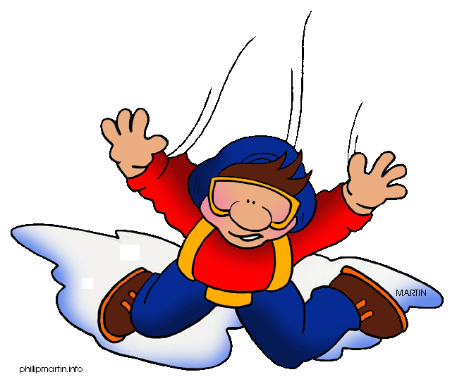
32. Ann thinks that Paul is ___________________ (lazy) of her children.
33. Skydiving is _________________________ (dangerous) jogging.
34. Messi is one of __________________________(famous) football players.
35. Ms Green is ______________________(nice) teacher at school.

- The most attractive
- Earlier than
- The most hard-working
- The richest
- Faster / safer than
- Better-looking than
- Older than
- The worst
- Shorter / fatter than
- More exciting than
- Farther than / the farthest
- More important than
- The luckiest
- More difficult than
- The most romantic
- The youngest
- Worse / better
- More delicious than
- More fashionable than
- The most helpful
- The hottest
- The highest
- Stronger than
- The most handsome
- Thinner
- More carefully
- More complicated
- Bigger
- Healthier
- The most talkative
- The heaviest
- The laziest
- More dangerous than
- The most famous
- The nicest

