Name:……………………………………….

Τι θα γίνεις όταν μεγαλώσεις? Πού θα δουλεύεις?

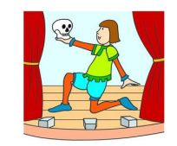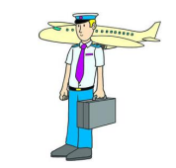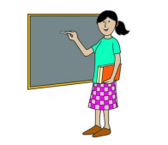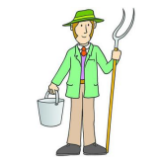Ταίριαξε τις εικόνες με τα επαγγέλματα.

actor

doctor

chef

teacher

pilot

farmer

Συμπλήρωσε τα κενά.

**I want to be**=θέλω να γίνω, **work**=δουλεύω, **drive**=οδηγώ



I want to be a …………………………… and work in a hospital.

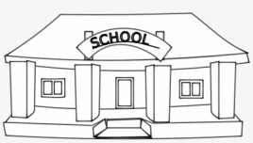

I want to be a …………………………… and work in a school.



I want to be an …………………………… and work in a theatre.

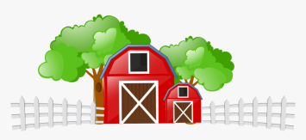

I want to be a …………………………… and work in a farm.



I want to be a …………………………… and work in a restaurant.

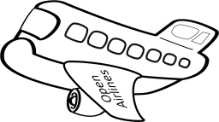

I want to be a …………………………… and drive an airplane.

*adapted from: learnenglishkids.britishcouncil.org*