ΝΑΜΕ: ________________________________

Look at the picture, read and write **yes,no** in the boxes.

Κοίτα προσεκτικά την εικόνα, διάβασε και βάλε **yes,no** στα κουτάκια.

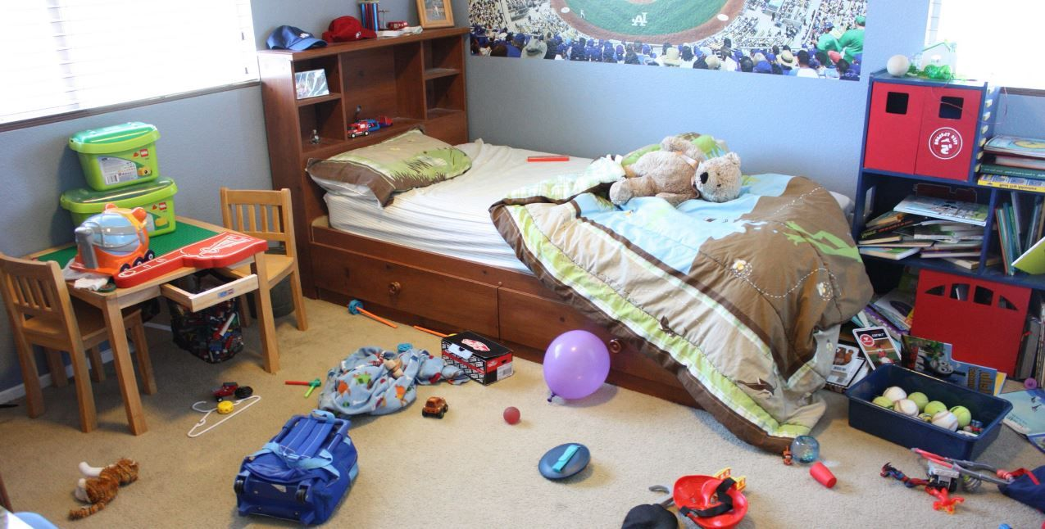

1. There is a bed.
2. There is a window.
3. There is a table.
4. There is a teddy.
5. There is a bike.
6. There is a schoolbag.
7. There is a balloon.
8. There is a bookcase.
9. There is a wardrobe.

10. There is a poster.

11. There is a lamp.

12. There is a T.V.

1. There is a red hat.
2. There is a jacket.
3. There is a book.