Here are ten sentences with gaps for practicing **past simple negative forms**, based on the life and career of El Greco:

1. El Greco ____________________ (not live) in Hania, Crete, for his entire life.
2. As a young man, El Greco ____________________ (not study) only Byzantine icon painting in Venice.
3. In 1567, El Greco ____________________ (not move) to Rome; he moved to Venice instead.
4. El Greco ____________________ (not meet) Titian in Rome; he met him in Venice.
5. El Greco ____________________ (not stay) in Rome until 1577; he left for Spain in 1576.
6. El Greco ____________________ (not die) in Madrid; he died in Toledo.
7. El Greco's paintings ____________________ (not show) only Byzantine styles; they also showed Italian influences.
8. El Greco ____________________ (not influence) only Picasso; he also influenced Cézanne.
9. Nikos Kazantzakis ____________________ (not title) his autobiography "A Tribute to Picasso"; he titled it "A Tribute to Greco".
10. Nikos Kazantzakis _________________________ (not write) about El Greco in his autobiography, he was just inspired by him

Here are ten sentences to practice **WH - past simple questions** based on the text about El Greco.

1. El Greco was born **in Hania, Crete**. ***(Where)***

_____________________________________________________________________________________

1. El Greco studied **Byzantine icon painting** as a young man in Hania. ***(What)***

_____________________________________________________________________________________

1. El Greco moved to Venice **in 1567**. (When)

_____________________________________________________________________________________

1. El Greco went **to Rome** after Venice in 1570. ***(Where)***

___________________________________________________________________________________

1. El Greco moved to Spain **to work with famous artists**. ***(Why)***

_____________________________________________________________________________________

1. El Greco lived and worked **in Toledo** until the end of his life. ***(Where***)

_____________________________________________________________________________________

1. El Greco was **73 years old** when he died in 1614. *(****How old)***

____________________________________________________________________________________

1. El Greco's paintings showed **both Byzantine and Italian styles, as well as strong Catholic religious elements. *(What)***

_____________________________________________________________________________________

1. El Greco's paintings influenced **many famous artists**, **such as Picasso and Cézanne** after his death. ***(Who)***

***_____________________________________________________________________________________***

1. Nikos Kazantzakis called his autobiography "A Tribute to Greco," **to honor him*. (Why)***

***_____________________________________________________________________________________***

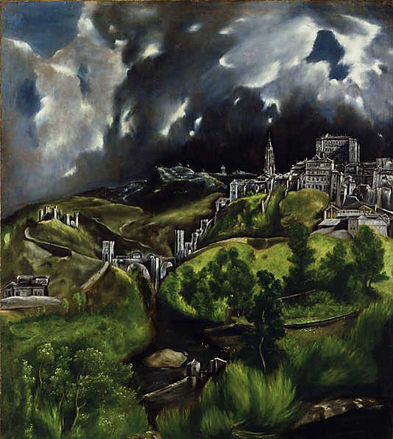

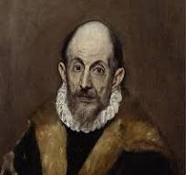

*El Greco,***View of Toledo***, Metropolitan Museum of Art*

***A self-portrait****, Metropolitan Museum of Art*