Do you know who these famous people are? Read and complete
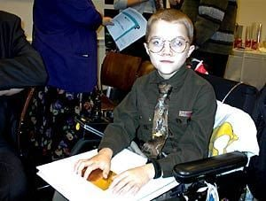  A child peace activist and poet who wrote great poems about Peace and Hope.  _______________________________________________________________________________________________ | 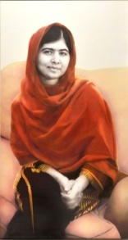  The youngest Nobel Prize winner who fought for girls’ education in Pakistan.  ________________________________________________________________________
An inspirational figure who fought against racial segregation(=διαχωρισμός) in the USA.  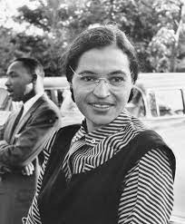  ________________________________________________________________________________________ | Α musician in the 60’s who sread the message of Peace all over the world.  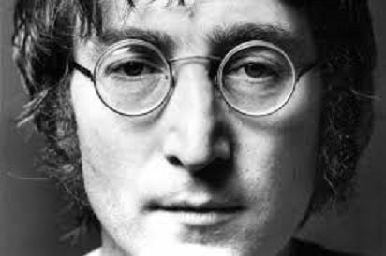  __________________________________________________________________________
A Nobel Prize winner nun of albanian origin.  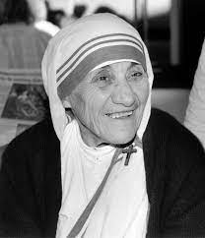  ________________________________________________________________________ | 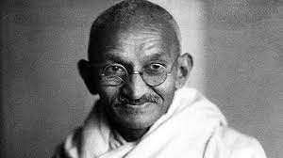  A philosopher and activist who used non-violence to free his home country, India from British rule.  ____________________________________________________________________
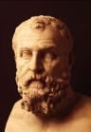  An ancient greek legislator(=νομοθέτης) who guided future democratic nations.  ___________________________________________________________________ | 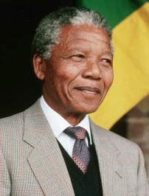  A leader who dedicated his life to abolishing(=κατάργηση) apartheid and establishing a democracy in South Africa.  _____________________________________________________________________________________
https://myhero.com/peacemaker, https://history-biography.com, https://kids.nationalgeographic.com https://learningapps.org/watch?v=pmx7ooe8k22

