Grade 3- Grammar: A/an, plural, I am.
Name: …………………………………………………………………………
- Complete with a/ an. (ex. An elephant)
………..igloo …………key
………..orange ………..yo-yo
…………monkey ………..umbrella
……….zebra ………..egg
………….Indian …………..nest

- How many? (1-one, 2-two, 3-three, 4-four, 5-five, 6-six, 7-seven, 8-eight, 9-nine, 10-ten). Ex.  Two elephants.

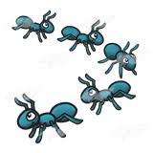
………………………… …………………………… ……………………….. ………………………………

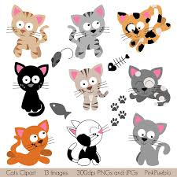

………………………….. …………………………… ……………………….. …………………………..
- Complete with am, is, are.
Kelly ……………….a girl. I ………………… fine, thank you.
Kelly ………………..strong. You …………………a tiger.
Billy ………………..a boy. One-Eye and One-Tooth……….. pirates.
We …………………. friends. I ………………..a pirate.
The parrot ………………… green. Fiona and I ……………….happy.

