<https://www.youtube.com/watch?v=dGzbmf8NEto&feature=youtu.be>

**CHILDREN RIGHTS**

**CRC: Convention of the Rights of Child:**

**Σύμβαση για τα Δικαιώματα του Παιδιού**

**What are the 4 main rights?**

* **survival**
* **health**
* **nutrition**
* **clean environment**
* **protection**
* **participation**
* **development**
* **education**
* **play**

**Explain the words:**

**survival:**

**health:**

**nutrition:**

**environment:**

**protect/ protection:**

**safety:**

**harm:**

**hurt:**

**bully:**

**participate/ participation:**

**be involved:**

**opinion:**

**development:**

**education:**

**Write a title for each picture:**

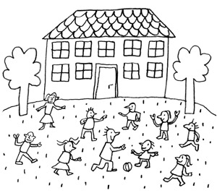

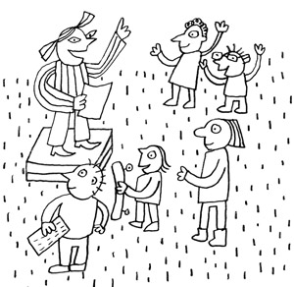

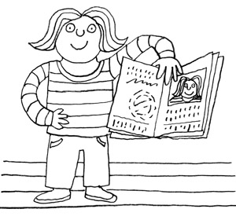

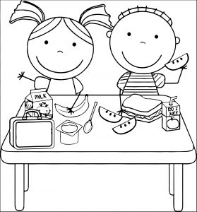

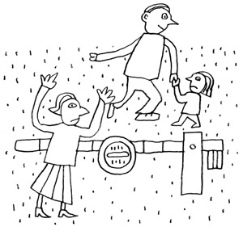

***pictures taken from: living-democracy.gr***