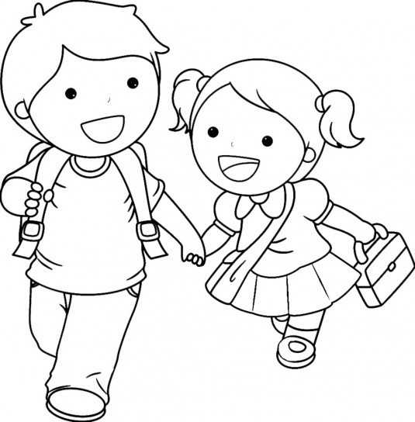

He is wearing a blue T-shirt, red trousers, black shoes and an orange bag.

She is wearing a green T-shirt, a purple skirt, yellow shoes and a pink bag.

