DEMONSTRATIVE PRONOUNS
Singular | Plural
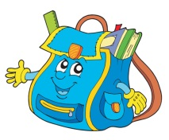  THIS  This is my schoolbag. |   THESE  These are my pencils.
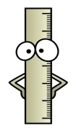  THAT  That is my ruler. |   THOSE  Those are my books.

- Choose the right pronoun.
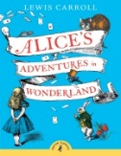
(this/that/these/those)
1._________ is my favourite book.
2.___________ students are happy. 3.___________ notebooks are mine. 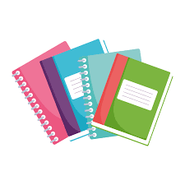
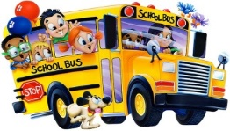
4.___________ is the school bus.

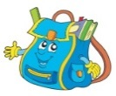
- Answer the questions.
Example: What is this? This is a schoolbag.
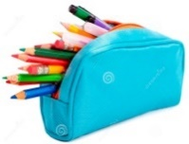
1. What is that? __________________________
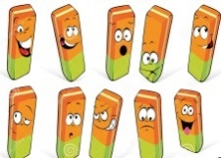
2. What are these? _________________________
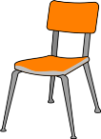
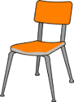
3. What are those? __________________________
4. What is this? __________________________ 