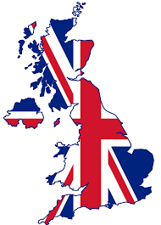
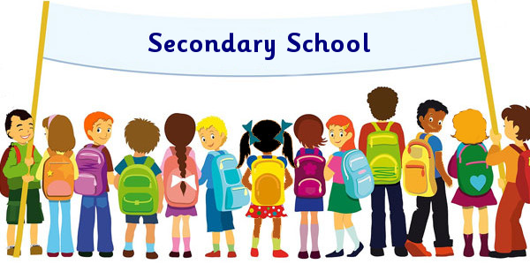

Schools in the U.K. ( https://www.youtube.com/watch?v=I3eu3qpq0GE)
Watch the video and fill in.
At secondary school lessons usually start at ………..o’clock. Students study lots of different ………………….. : Science, Maths, Music and …………….They also learn to …………. Students have their lunch at school. They eat in the school …………………. You can have a school …………………. or you can bring your lunch from ………….. Lunchtime is usually one hour. There’s always time to play games or talk with friends in the …………………..
Secondary schools often have a school ……………………. Trousers for boys and trousers or a skirt for girls. Then a shirt, a tie and a …….…..…..or a jumper. Afternoon lessons usually ……………………. at 3 o’clock. Secondary schools usually have after school clubs. There are ……………. clubs like basketball and gymnastics. And other clubs like ………….. club. You can play an ……………………. in the school orchestra too. That school orchestra looks fun! In the UK the school summer ……………………. are 6 weeks! They start in July and end in ……………………ll in: secondary/ subjects/ start/ playground/ cook/ instrument/ canten/ school clubs
Read and decide if the sentences are True or False. Correctoonesonesonessentences.

1. Lessons usually start at eight o’clock.

2. Students go home for lunch.
3. Secondary students rarely wear school uniforms.
4. Lessons finish at three o’clock.
5. After school students can go to clubs.
6. The school holidays are from June to September.
Answer the questions.

- Would you like to have a cooking class at school?
- Do students in Greece eat their lunch at school?
- Would you like to wear a school uniform?
- What after school clubs would you like to have at your school?
- How long are the school summer holidays in your country?
Answer the questions.

