PARTS OF THE FACE
Fill in the gaps with the words : eyes ,mouths , hair ,ears , noses , teeth
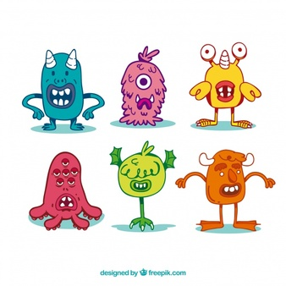
In the picture you can see 6 monsters !They are very strange!
All monsters have got cute little mouths!
The pink one has got six ___________!
The purple one ,the green one and the orange one are the only monsters with ___________!
The orange one has got three ___________!
The green one has got two __________!
The blue one, the pink one and the orange one , are the only monsters with __________!

