**Class Handouts**

[**https://e-class.sch.gr**](https://e-class.sch.gr)

Μάθημα: 9050830427

***Unit 3 Talking about a Town in Greece***

**Kastoria**

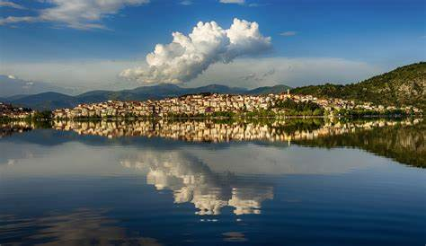

**The city:** Kastoria is a city in northern [Greece](https://en.wikipedia.org/wiki/Greece) in the [region](https://en.wikipedia.org/wiki/Modern_regions_of_Greece) of [Western Macedonia](https://en.wikipedia.org/wiki/Western_Macedonia). It is the capital of [Kastoria](https://en.wikipedia.org/wiki/Kastoria_(regional_unit)" \o "Kastoria (regional unit)) regional unit, in the [geographic region](https://en.wikipedia.org/wiki/Geographic_regions_of_Greece) of [Macedonia](https://en.wikipedia.org/wiki/Macedonia_(Greece)).

**The location:** It is situated on a promontory* on the western shore of [Lake Orestiada](https://en.wikipedia.org/wiki/Lake_Orestiada), in a valley surrounded by [limestone](https://en.wikipedia.org/wiki/Limestone) **  mountains.

**Landmarks:** The town is known for its many [Byzantine](https://en.wikipedia.org/wiki/Byzantine_Empire) churches, [Byzantine](https://en.wikipedia.org/wiki/Byzantine_architecture) and [Ottoman](https://en.wikipedia.org/wiki/Ottoman_architecture)-era domestic architecture, its lake and its [fur clothing](https://en.wikipedia.org/wiki/Fur_clothing) industry.

The text above is divided into three paragraphs. Read it again and match the topics with the paragraphs. You will understand the way we organize our text about a place.

|  |  |
| --- | --- |
| 1.The famous places a visitor wants to see in Kastoria | a. paragraph 2 |
| 2. Which part of Greece Kastoria is placed at | b. paragraph 3 |
| 3. What are the city’s surrounding | c. paragraph 1 |

*promontory=ακρωτήριο ** limestone= ασβεστόλιθος

**Activity 1**

**Your school organizes a three day visit to a town in Northern Greece. You need to vote about going to Kastoria or Ioannina.**

**In groups of four, choose which city you want to visit and make a list of the things you want to do there. Then tell the class about your decision.**

**City I want to visit**:…………………………………………………………………..

**Landmarks I want to see**: …………………………………………………………..

**Activities I want to do there** (e.g. visit museums, castles, seat by the lake, go shopping):…………………………………………………………………………………

**Activity 2**

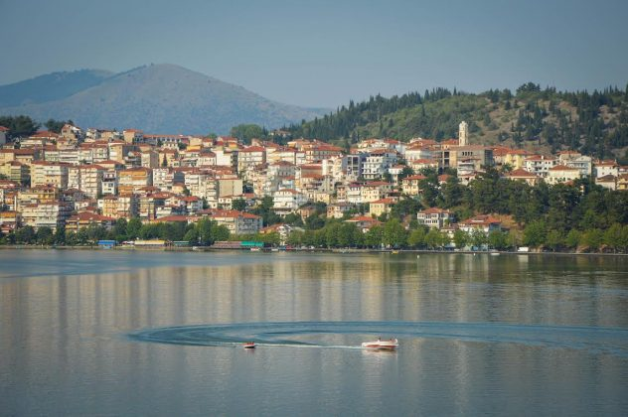 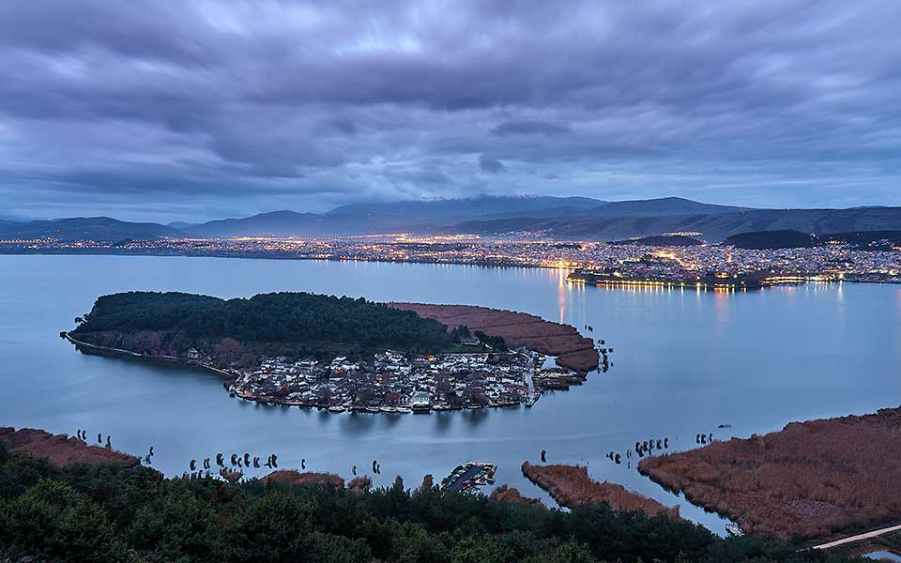

**Activity 2**

**Vote which city your school will visit. Put a tick √**

|  |  |  |
| --- | --- | --- |
| **STUDENT GROUPS** | **Ioannina** | **Kastoria** |
| **Group A (St names)** |  |  |
| **Group B** |  |  |
| **Group C** |  |  |
| **Group D** |  |  |
| **Group E** |  |  |

And the winner is……………………..

**Homework Assignment**

**You write an email to your friend Dimitris in Thessaloniki informing him about your class decision to visit a Northern Greece city before the Easter Holiday (about 60 words)**

Dear Dimitris,

My class have decided to visit………………………………………………………………………………………………………………………………………………………………………………………………………………………………………………………………………………………….

We chose this city because……………………………………………………………………………………………………

You can do many things there such as………………………………………………………………………………….

I am excited about this trip and looking forward to it.

Tell me about you.

Love,

*……………..(Your name)*

………………………..

**Dear Dimitris,**

**My class have decided to visit …………………………………………………………………………………………………………………………………………………………………………………………………..**

**We chose this city because……………………………………………………………..**

**You can do many things there such as…………………………………………………**

**I am excited about his trip.**

**Talk soon**

**Love,**

**………………..**