**BODY**

**A. Βρες το μέρος του σώματος.**

**leg-ear-hand-face-eye**

1. The part at the end of your arm------------------------------
2. The part in your head that you can see with--------------
3. The front part of your head------------------------------------
4. The part of the body that you use for walking------------
5. The part that is used for hearing-----------------------------

**B. Σωστό ή λάθος.**

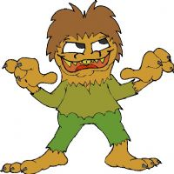

1. I am a monster------------------
2. I’ve got lots of eyes-------------
3. I haven’t got hair----------------
4. I’ve got yellow teeth-----------
5. My mouth is big-----------------
6. I’ve got a big nose--------------
7. My eyes are small--------------