**HAVE GOT (έχω)**

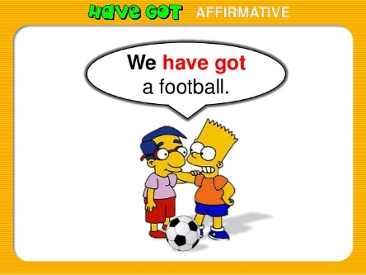

Κατάφαση Σύντομος τύπος Ερώτηση

I have got I’ve got Have I got?

You have got you’ve got Have you got?

He has got he’s got Has he got?

She has got she’s got Has she got?

It has got it’s got Has it got?

We have got we’ve got Have we got?

You have got you’ve got Have you got?

They have got they’ve got Have they got?

Άρνηση

I have not got (haven’t)

You have not got (haven’t)

He has not got (hasn’t)

She has not got (hasn’t)

It has not got (hasn’t)

We have not got (haven’t)

You have not got (haven’t)

They have not got (haven’t)