**THE ANIMAL SCHOOL-ΑΣΚΗΣΕΙΣ**

**Βάλε τις λέξεις στη σωστή κατηγορία.**

schoolbag, bedroom, cheese, ant, yoghurt, weasel, honey, hat,

crocodile, jacket, kitchen, lettuce, bathroom, pencil, socks, living room,

rubber, parrot, notebook, shoes

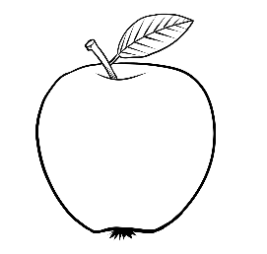**FOOD: ------------------------------------------------------------------------**

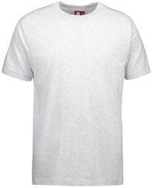**CLOTHES:--------------------------------------------------------------------------**

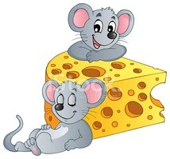**ANIMALS:-----------------------------------------------------------------------**

**HOUSE:---------------------------------------------------------------------**

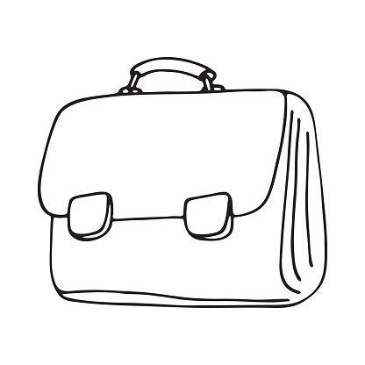**SCHOOL THINGS:-----------------------------------------------------**

**Κύκλωσε τη λέξη που δεν ταιριάζει.**

1. monkey, bedroom, kangaroo, panda, crocodile

2. eye, cellar, tooth, ear, lips

3. socks , jacket, shoes, dragon, hat

4. spring, summer, nuts, autumn, winter

5. Monday, Tuesday, Friday, July, Sunday

6. ham, pears, sweets, mouth, potatoes

**What's the time? Ζωγράφισε και γράψε την ώρα.**

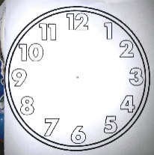 **3:30----------------------------------------------------------------**

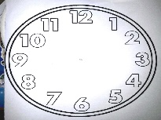 **11:00----------------------------------------------------------------**

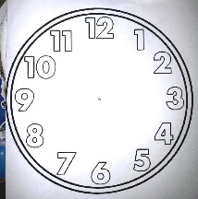 **6:00-------------------------------------------------------------------**

**7:30--------------------------------------------------------------------**

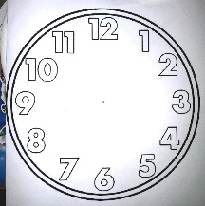 **8:00-------------------------------------------------------------------**

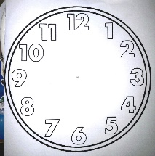**5:00----------------------------------------------------------------------**

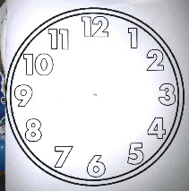**2:30-----------------------------------------------------------------------**

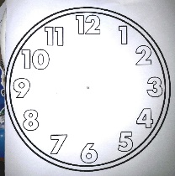 **1:30------------------------------------------------------------------------**

**ΔΣLe**

Γ

**: A bright worldΓ**

It's cool to be different, everybody is **unique**,

Different is ---------------- and nobody is weak!

Everybody is different, everybody is nice,

What a pity, what a shame,

how -----------------to be the same!

Respect my likes, respect my ----------------,

and the world will be so ------------------------!

I can ---------------------you, you can help me,

everything will be alright!

(**κείμενο βιβλίου σελίδα 74**)

**Ταίριαξε τις λέξεις.**

everybody=όλοι same=ίδιος

strong=δυνατός sad=λυπημένος

different=διαφορετικός nobody=κανείς

empty=άδειος big=μεγάλος

small=μικρός full=γεμάτος

happy=ευτυχισμένος weak=αδύναμος

