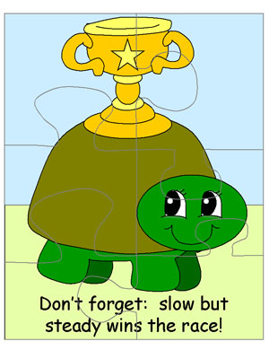

**THE TORTOISE AND THE HARE**

**ΑΣΚΗΣΗ**

**Βάλε τις λέξεις στα κενά.**

two-tortoise-race-nap-fast-rabbit-lazy-going-finish line-win

In the story of the Tortoise and the Hare, there were ------------important characters. One was a ------------------and the other was a -------------------. One day they decided to have a -----------. No one thought that the tortoise would ----------------, because the rabbit was so ---------------!

However, the rabbit got ---------------------and decided to take a -------------. When he was asleep, the tortoise kept on-------------------and made it all the way to the ---------- ----------before the rabbit even woke up.