**TO BE**

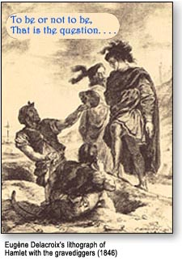

**ΑΣΚΗΣΕΙΣ**

1. **Βάλε am-is-are**

Top of Form

|  |  |
| --- | --- |
| 1.jpg | I a boy. |
| 2.gif | You happy. |
| 3.gif | He a man. |
| 4.jpg | She a girl. |
| 5.gif | It a cat. |
| 6.gif | We children. |
| 7.gif | You twins. |
| choir.png | They friends. |

**Β. Γράψε την άρνηση**

Top of Form

|  |  |
| --- | --- |
| https://agendaweb.org/exercises/verbs/imaxes/be-boy.jpg | I am a boy. |
| a boy. |
| https://agendaweb.org/exercises/verbs/imaxes/be-girl.jpg | You are a girl. |
| a girl. |
| https://agendaweb.org/exercises/verbs/imaxes/be-friend.gif | He is my friend. |
| my friend. |
| https://agendaweb.org/exercises/verbs/imaxes/be-mother.gif | She is my mother. |
| my mother. |
| https://agendaweb.org/exercises/verbs/imaxes/be-dog.jpg | It is a dog. |
| a dog. |
| https://agendaweb.org/exercises/verbs/imaxes/be-happy.jpg | We are happy. |
| happy. |
| https://agendaweb.org/exercises/verbs/imaxes/be-tall.jpg | You are tall. |
| tall. |
| https://agendaweb.org/exercises/verbs/imaxes/be-family.jpg | They are a family. |
| a family. |

1. **Γράψε ερώτηση και άρνηση.**
2. I am a student-----------------------------------------------------------------------------------------------------------------------------------------------
3. She is a nurse-----------------------------------------------------------------------------------------------------------------------------------------------
4. He is a doctor-----------------------------------------------------------------------------------------------------------------------------------------------
5. They are teachers------------------------------------------------------------------------------------------------------------------------------------------
6. It is a chair---------------------------------------------------------------------------------------------------------------------------------------------------
7. You are a boy----------------------------------------------------------------------------------------------------------------------------------------------
8. We are girls--------------------------------------------------------------------------------------------------------------------------------------------------
9. He is fat-------------------------------------------------------------------------------------------------------------------------------------------------------
10. Helen is tall-------------------------------------------------------------------------------------------------------------------------------------------------
11. The bird is small------------------------------------------------------------------------------------------------------------------------------------
12. **Βάλε am-is-are**

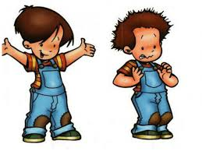

PETER AND CARL

Hello! My name _____ Carl. I _____ from Australia. I _____ 13 years old and I _____ a student at a secondary school. My father _____ a teacher and my mother _____ a nurse. My father _____ 45 years old and my mother _____ 42. We live in the city center. Our house _____ a small flat but it _____ new and modern .My grandparents live with us. They _____ very nice. This boy _____ Peter. He _____ my best friend .He _____ a student at high school. He _____ 15 years old.