**A GOOD SALAD**

|  |  |  |
| --- | --- | --- |
|  |  | **A:** I love salads. **B:** Me too. **A:** I usually eat a simple salad. **B:** What do you put in it? **A:** Just lettuce, tomato, and celery. **B:** That's it? **A:** I add some pepper and salt. **B:** I always put cheese in my salads. **A:** Yes, cheese is nice. **B:** What kind of dressing do you use? **A:** I pour lots of French dressing on top. **B:** Me too. French dressing is so delicious! Who cares about calories  **ΑΣΚΗΣΗ (TRUE- FALSE )**   1. They love salads---------------- 2. They care a lot about calories---------- 3. They put cucumber in the salad-------- 4. They hate French dressing-------------- 5. They add salt------------------------------- 6. They put celery, tomato, lettuce and chicken------------------- |

**A REAL MEAL**

|  |  |  |
| --- | --- | --- |
|  |  | **A:** I like this hotel. **B:** What do you like about it? **A:** We get a free breakfast. **B:** Coffee and a roll? **A:** No, a real breakfast. **B:** Bacon and eggs? **A:** With toast, ham, sausage, fresh fruit, and juice. **B:** Wow! That is nice. Let's stay for two nights. **A:** And the rooms are clean, too. **B:** Do they allow pets? **A:** No pets, no smoking. **B:** I like that. Let's stay three nights.  **ΑΣΚΗΣΗ ( TRUE- FALSE )**   1. They will stay in this hotel for a week------------ 2. Smoking is allowed ----------------- 3. They will have free breakfast------------- 4. They cannot get any pet----------------- 5. They are excited-------------------- 6. The rooms are dirty------------------- |

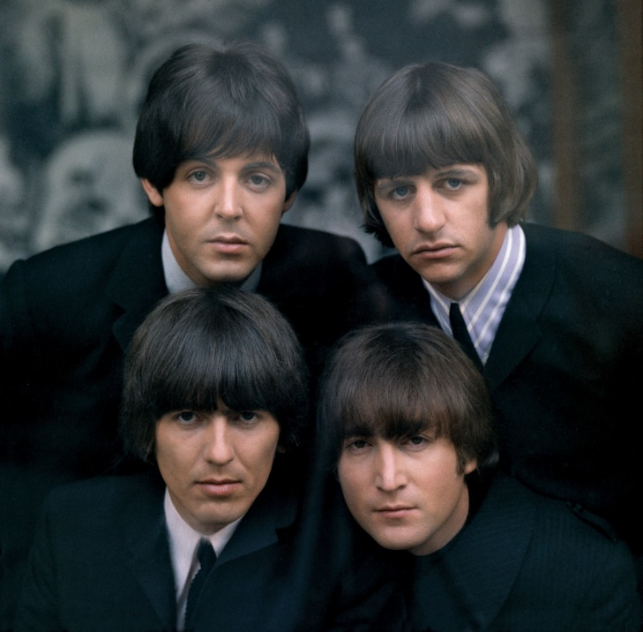

Οι The Beatles ήταν αγγλικό ροκ συγκρότηµα της δεκαετίας του 1960 (αναφέρονταν και ως "Σκαθάρια" στα ελληνικά) από το Λίβερπουλ, αποτελούµενο από τον τραγουδιστή και κιθαρίστα Τζον Λένον, τον τραγουδιστή και µπασίστα Πωλ ΜακΚάρτνεϋ, τον κιθαρίστα Τζωρτζ Χάρισον και τον ντράµερ Ρίνγκο Σταρ.