**ΓΡΑΨΤΕ ΤΗΝ ΕΘΝΙΚΟΤΗΤΑ**

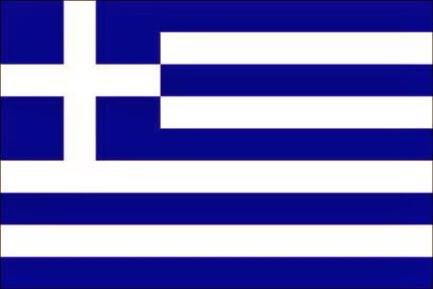

GREECE 🡪

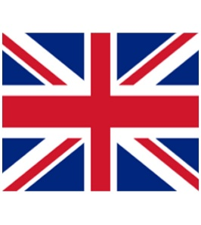

ENGLAND 🡪



UNITED STATES OF AMERICA 🡪

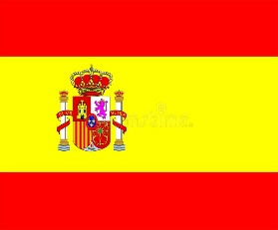

SPAIN 🡪

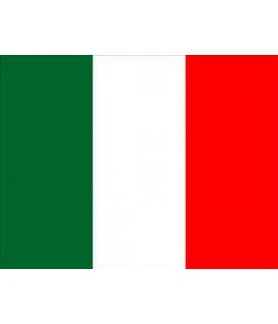

ITALY 🡪

BRAZIL 🡪 



CHINA 🡪

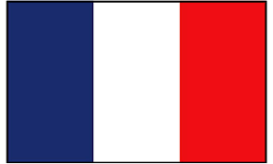

FRANCE 🡪



GERMANY 🡪

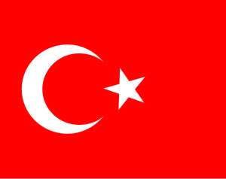

TURKEY 🡪

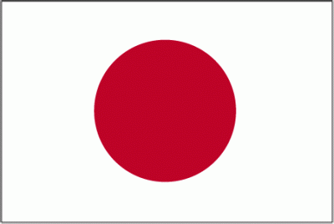

JAPAN 🡪



RUSSIA 🡪



EGYPT 🡪

\***The Union Jack**: the flag of the U. K. is known as Union Jack (Jack is the word used for flag in sailing). The red cross on the flag represents England, the white diagonal cross on a blue background represents Scotland and the red diagonal cross represents Ireland. Wales is not represented on the flag, as it is a principality of England. It was introduced as the national flag in 1603, when England and Scotland were united and the red diagonal cross of Ireland was added in 1801, when Ireland became part of the U.K.