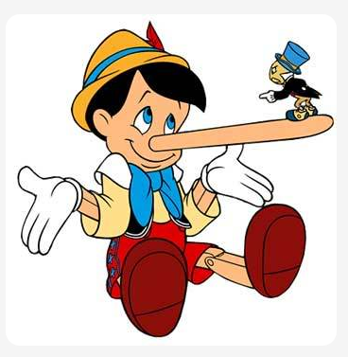

PINOCCHIO

ΑΣΚΗΣΗ( TRUE- FALSE )

1. Pinocchio is a puppet boy--------------------------------
2. His father’s name is Beppino----------------------------
3. At night a fairy appears------------------------------------
4. Pinocchio is angry with the fairy------------------------
5. Pinocchio goes to school---------------------------------
6. The circus tent is awful------------------------------------
7. The circus master gives him six coins-----------------
8. A cat and a fox fool him-----------------------------------
9. His nose goes longer each time he lies---------------
10. He doesn’t go to Toyland-------------------------
11. He saves his father--------------------------------
12. The fairy turns him into a human---------------