**PLURALS**

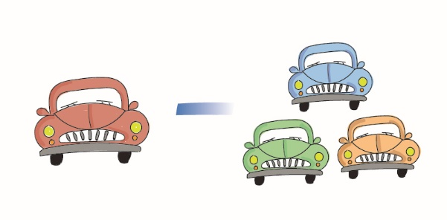

**ΑΣΚΗΣΗ**

Α. Γράψε τον πληθυντικό των ουσιαστικών.

1. pencil--------------------
2. berry---------------------
3. desk---------------------
4. basket-------------------
5. key-----------------------
6. princess----------------
7. bench-------------------
8. glass--------------------
9. torch---------------------
10. apple--------------------
11. wife----------------------
12. ox------------------------
13. sandwich--------------
14. octopus----------------
15. chair--------------------
16. family------------------
17. woman----------------
18. wolf--------------------
19. baby-------------------
20. bag--------------------
21. bus-------------------
22. bat-------------------
23. monkey------------
24. kite-----------------
25. thief----------------
26. watch-------------
27. goose--------------
28. fairy---------------
29. leaf---------------
30. man---------------
31. boy---------------
32. match------------
33. beach------------
34. egg---------------
35. city----------------
36. roof---------------
37. toy----------------
38. lady--------------
39. dish--------------
40. dress------------
41. arch--------------
42. child--------------
43. butterfly-----------
44. sheep-------------
45. book---------------
46. knife---------------
47. box-----------------
48. country-------------
49. church-------------
50. fox-----------------
51. kiss----------------
52. story---------------
53. foot-----------------
54. mouse-------------
55. life------------------
56. party---------------
57. star----------------
58. class--------------
59. table--------------
60. ruler--------------
61. doll----------------
62. day---------------
63. brush-------------
64. banana-----------
65. cherry-------------
66. cow---------------
67. hat----------------