**ΑΣΚΗΣΕΙΣ (ACTIVITY σελ. 44)**

Ταίριαξε τις προτάσεις.

1. The Wright brothers invented
2. Alexander Fleming discovered
3. Marilyn Monroe
4. Mother Teresa, a Catholic nun,
5. Kostis Palamas
6. Albert Einstein was the scientist who
7. Joan of Arc
8. Maria Callas
9. Konstantinos Paleologos was
10. Odysseas Elitis and George Seferis were the two Greek poets that

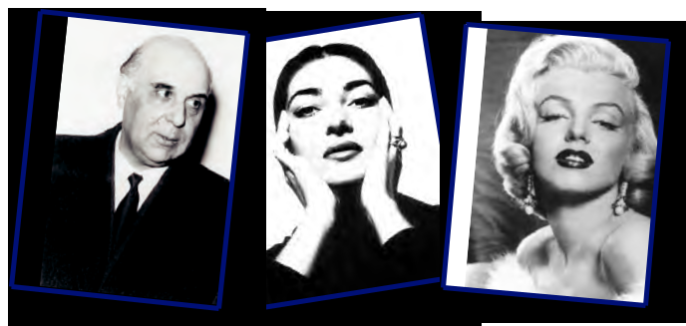

a. was burnt at the stake in 1431.

b. developed the theory of relativity.

c. was a Greek opera singer who became famous all over the world.

d. were awarded the Nobel Literature prize.

e. the last Emperor of the Byzantine Empire.

f. penicillin in 1928.

g. the aeroplane in 1903.

1. was an American actress, singer and dancer.
2. wrote the Hymn of the Modern Olympic Games.
3. was awarded the Nobel Peace Prize in 1979.

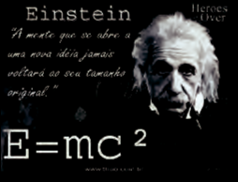

*Βάλε τις λέξεις στα κενά.*

1. Shakespeare was a British ………………………… . He wrote ……………………and

……………………………… . “Hamlet” and “Romeo and Juliet” are two of his most

………………………………. plays.

1. Nadine learnt a lot about Shakespeare in her ……………………. class.
2. Nadine wants Kostas to do her a ……………………… . She wants him to send her some information about Greek writers, ……………………………. or ………………………
3. Konstantinos Kavafis was a Greek ……………… who lived in Alexandria, Egypt.
4. Greece and Italy are ………………………………. countries.

|  |  |  |  |  |
| --- | --- | --- | --- | --- |
| **culture** | **comedies** | **artists** | **playwright** | **favour** |
| **tragedies** | **Mediterranean** | **popular** | **scientists** | **poet** |
|  |  |  |  |  |