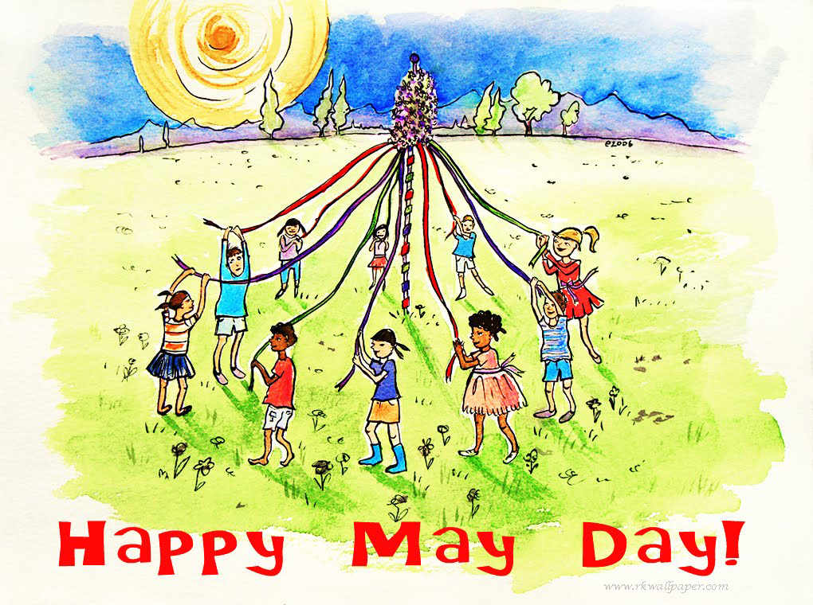

May Day is a holiday that celebrates the return of Spring. It usually takes place on May 1. Many people celebrate May Day with festivals or flowers. One of the oldest May Day traditions is the maypole. A maypole is a tree trunk or pole decorated with colorful ribbons. On May Day dancers hold the ribbons and dance around the pole. May Day is not an official holiday in the United States. In the United Kingdom it is a bank holiday that is celebrated on the first Monday in May. In some countries May Day is a holiday that honors workers, similar to [**Labor Day**](https://kids.britannica.com/kids/article/Labor-Day/353356) in the United States.

In addition to the maypole, another tradition is the giving of May Day baskets. Children make the baskets out of paper and fill them with flowers. They then bring the baskets to their neighbors’ homes. They leave a basket at the door, knock, and then hide while the neighbor answers.

People in Hawaii call the holiday Lei Day and wear leis, or necklaces made of flowers. In some countries in Europe people decorate their homes and public places with flowers. Others eat special foods, plant trees or sing songs about spring. To honor workers some countries hold parades and ceremonies.

May Day began as a spring festival in Europe. In ancient times and during the Middle Ages (ad 500–1500) Europeans welcomed the end of winter. With the arrival of spring, they were able to grow crops again. They celebrated with eating, singing, and dancing. The tradition of May Day as a workers’ holiday began in the late 1800s.