**OLIVER TWIST**

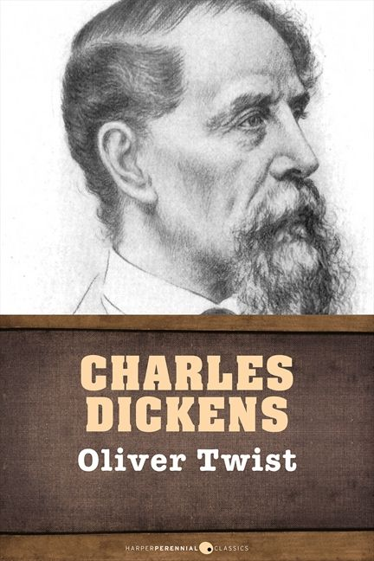

ΑΣΚΗΣΗ ( TRUE OR FALSE)

1. Oliver is an orphan---------------------------
2. In 1840 many children used to work-----------------------
3. Oliver has never been to a workhouse--------------------
4. Oliver runs away to a little village---------------------------
5. In the story Fagin is a magician-----------------------------
6. The Arthur Dodger steals a book from Mr. Brownlow----------
7. It’s a story with good ending---------------------------------

