**PLURALS**

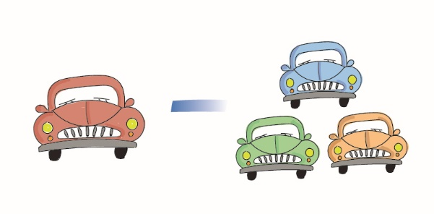

**ΑΣΚΗΣΗ**

Α. Γράψε τον πληθυντικό των ουσιαστικών.

1. pencil--------------------
2. berry---------------------
3. desk---------------------
4. basket-------------------
5. key-----------------------
6. princess----------------
7. bench-------------------
8. glass--------------------
9. torch---------------------
10. apple--------------------
11. wife---------------------
12. sandwich--------------
13. octopus----------------
14. chair--------------------
15. family------------------
16. woman----------------
17. wolf--------------------
18. baby-------------------
19. bag--------------------
20. bus-------------------
21. bat-------------------
22. monkey------------
23. kite-----------------
24. thief----------------
25. watch-------------
26. fairy---------------
27. leaf---------------
28. man---------------
29. boy---------------
30. match------------
31. beach------------
32. egg---------------
33. city----------------
34. toy----------------
35. lady--------------
36. dish--------------
37. dress------------
38. arch--------------
39. child--------------
40. butterfly-----------
41. book---------------
42. knife---------------
43. box-----------------
44. country-------------
45. church-------------
46. fox-----------------
47. kiss----------------
48. story---------------
49. foot-----------------
50. life------------------
51. party---------------
52. star----------------
53. class--------------
54. table--------------
55. ruler--------------
56. doll----------------
57. day---------------
58. brush-------------
59. banana-----------
60. cherry-------------
61. cow---------------
62. hat----------------

f, fe---------------------ves

leaf------------------leaves

life----------------------lives