Past simple

(study)-------> I studied= μελέτησα

Affirmative Interrogative Negative (full) Negative(short form)

|  |  |  |  |
| --- | --- | --- | --- |
| I studied | Did I study? | Ididnotstudy | I didn’tstudy |
| Youstudied | Didyoustudy? | Youdidnotstudy | Youdidn’tstudy |
| Hestudied | Didhestudy? | Hedidnotstudy | Hedidn’tstudy |
| Shestudied | Didshestudy? | Shedidnotstudy | Shedidn’tstudy |
| Itstudied | Diditstudy? | Itdidnotstudy | Itdidn’tstudy |
| Westudied | Didwestudy? | Wedidnotstudy | Wedidn’tstudy |
| Youstudied | Didyoustudy? | Youdidnotstudy | Youdidn’tstudy |
| Theystudied | Didtheystudy? | Theydidnotstudy | Theydidn’tstudy |

(Take)--------> I took=πήρα

Affirmative Interrogative Negative (full) Negative(short form)

|  |  |  |  |
| --- | --- | --- | --- |
| I took | Did I take? | I did not take | I didn’t take |
| You took | Didyou take? | You did not take | You didn’t take |
| He took | Did he take? | He did not take | He didn’t take |
| She took | Didshe take? | She did not take | She didn’t take |
| It took | Didit take? | It did not take | It didn’t take |
| We took | Didwe take? | We did not take | We didn’t take |
| You took | Did you take? | You did not take | You didn’t take |
| They took | Didthey take? | They did not take | They didn’t take |

Yesterday=χθες🡪My friend and I went to the Olympic stadium yesterday.

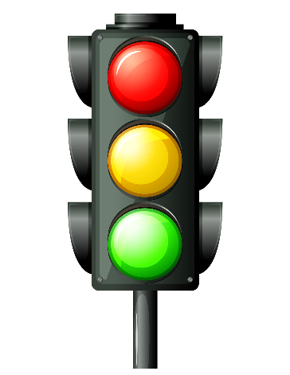

[Αυτή η φωτογραφία](http://pngimg.com/download/56252) από Άγνωστος συντάκτης με άδεια χρήσης [CC BY-NC](https://creativecommons.org/licenses/by-nc/3.0/)

Ago = πριν (2 days ago)🡪 I met Alex 9 years ago.

Last =περασμένο🡪Last week I played in the snow!

When= πότε🡪When did you study? 🡪 I studied last night.

Present Past Past Participle

|  |  |  |  |
| --- | --- | --- | --- |
| Είμαι | Be(am/is/are) | Was/were(ήμουν) | been |
| Γίνομαι | Become | Became(έγινα) | become |
| Ξεκινώ | Begin | Began(άρχισα) | Βegun |
| Δαγκώνω | bite | Bit (δάγκωσα) | bitten |
| φυσώ | blow | Blew (Φύσηξα) | blown |
| σπάω | break | Broke (έσπασα) | broken |