Create the dialogue by putting each section in the correct order.
(Introduction: Anne Boleyn was one of the wives of King Henry VIII, 1491-1547)

..... | Because I'm a ghost. But don't be afraid. I won't harm you. | A
..... | Why can't I touch you?
..... | My name's Anne Boleyn.
..1.. | Hello! Who are you?
..... | Yes, I know. I'm very sad. | B
..... | But do ghosts cry? I can see tears running on your face.
..... | Because my husband killed me.
..... | But why?
..... | Killed you? Who was your husband?. | C
..... | But why did he kill you?
..... | King Henry VIII. And I was his queen.
..... | Because I gave him a daughter.
..... | Killed you? That's preposterous! | D
..... | Well, I suppose it made a lot of difference to my husband.
..... | Well, he didn't want a girl. He wanted a son.
..... | I don't understand. What's the difference between a son and a daughter?
..... | And he killed you himself? | E
..... | Yes, I suppose he was. That's why I wander in the Tower of London, thinking of the old days. And I can only cry.
..... | Well, not exactly. He ordered his soldiers to cut off my head.
..... | Oh, my God! I can't believe it! He must have been a cruel person!

Points: ....... / 36


C. Look at the pictures and write what Nadine did last Sunday.
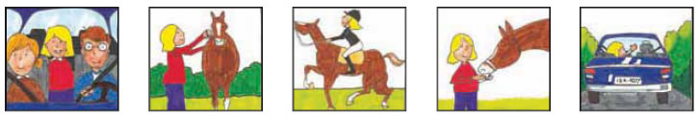

Last Sunday was a special day for Nadine. .............................................................................
......................................................................................................................................................................................
......................................................................................................................................................................................
......................................................................................................................................................................................
...............................................................................................

Points: ....... / 28

D. A horrible weekend.

The Antoniou family went away for the weekend, but they had a terrible time. Match the sentences to find out why.
- so they had to wait in the sun for over half an hour for the tyre to be replaced.
- so they didn't buy any souvenirs.
- they decided to sit by the pool instead.
- so they had to walk there in the hot sun.
- because it looked dirty.
- they all got a stomach ache.
- and their beds were quite uncomfortable.
- as there was a disco nearby, so they couldn't sleep at night.
- The hotel room was very small
- Everything was expensive,
- The food was so bad that
- They didn't swim in the sea
- The beach was so dirty that
- The hotel roomwas noisy
- Their car had a flat tyre,
- The nearest supermarket was half an hour away from the hotel

