2. Can you talk about what Easel the weasel and Cole the mole are doing?

run, eat, drink, read, sleep

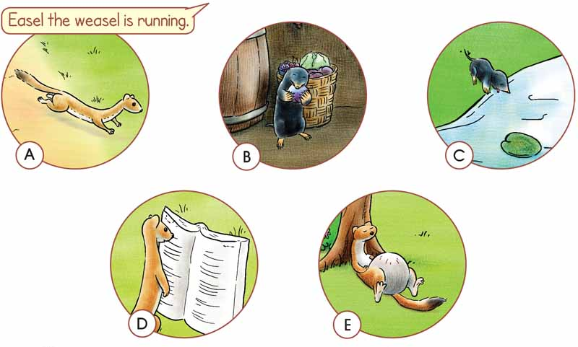

Picture B----------------------------------------------------------------------------------------------

Picture C-----------------------------------------------------------------------------------------------

Picture D-----------------------------------------------------------------------------------------------

Picture E------------------------------------------------------------------------------------------------

3. Let's play!

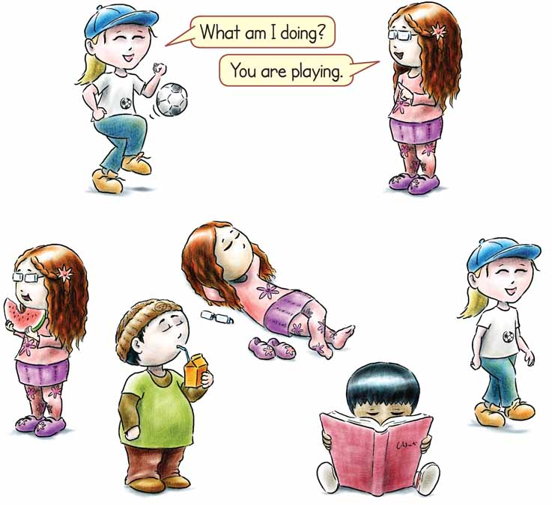

1 Lena ------------------------------------ (eat) a slice of watermelon.

2 Lena ----------------------------------------- (sleep).

3 Tammy ---------------------------------------(walk).

4 Yuri --------------------------------------------- (drink) some orange juice.

5 Yuri --------------------------------------(read) a book.

|  |
| --- |
| 4. Can you spy the 7 funny things in the cellar?  4. Μπορείς να ”κατασκοπεύσεις” 7 περίεργα πράγματα στο κελάρι;  εικόνα |

|  |
| --- |
|  |