Tell the Time

Can you tell the time?

Take a look at this video!

<https://www.youtube.com/watch?v=cd_eyEJKa_A>

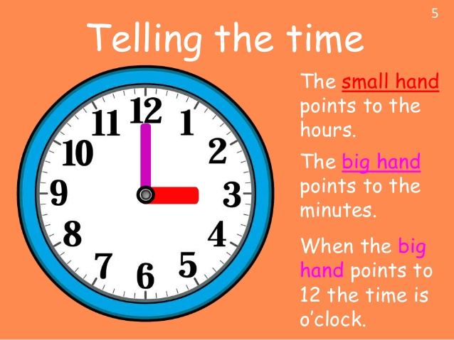

So, what time is it?

It is three o’clock.

https://www.google.com/url?sa=i&url=https%3A%2F%2Fwww.tes.com%2Flessons%2FLKLmdyza7DCijw%2Fparts-of-a-clock&psig=AOvVaw1Pkihso9lLpfUGxwULD6Ja&ust=1590520064343000&source=images&cd=vfe&ved=0CAIQjRxqFwoTCLC8upPbz-kCFQAAAAAdAAAAABAM

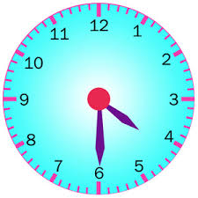What time is it?

It is half past four.

<https://k8schoollessons.com/telling-time-half-past-activity-3/>