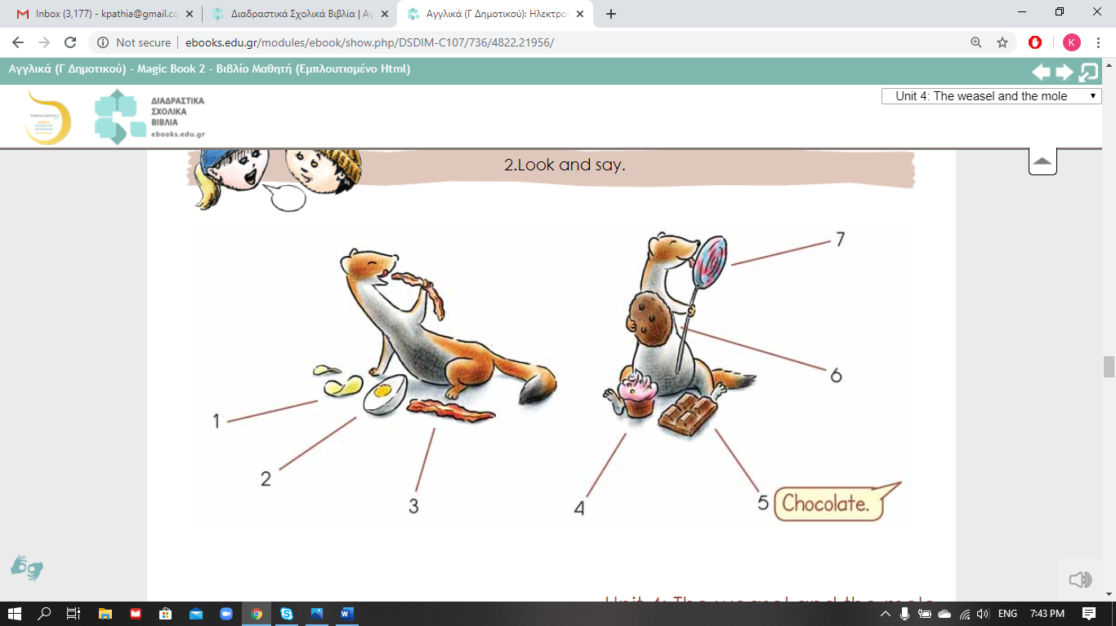Easel the weasel likes eating healthy and unhealthy food. Can you tell me what kind of food Easel likes?

Listen to the song and complete the words.

Άκουσε το τραγούδι και συμπλήρωσε τις μέρες που λείπουν.

<http://photodentro.edu.gr/v/item/video/8522/998>

Monday, 1T-----------------, tasty cherries,  
2W-----------day, 3 Th-------day, plums and berries.  
Friday, and 4 S-----------day, nuts and honey.  
Sunday, lettuce is so yummy!  
Eating right can make you happy!