Gosh! This wall is very tall! 

Oh, but look! A hole so small! 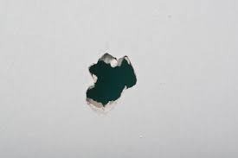

A full cellar

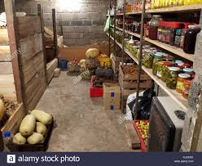

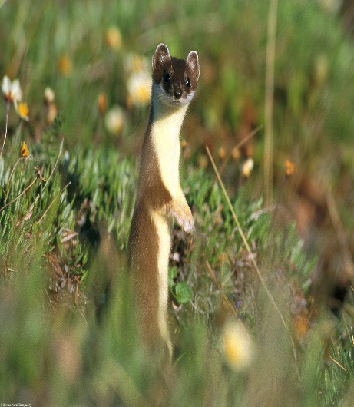

This is a thin weasel.

A fat weasel 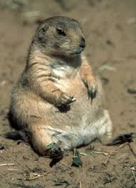 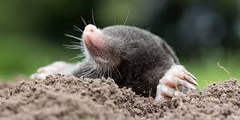A mole

Please visit this page and listen to it 3x (Three times)

<http://photodentro.edu.gr/v/item/video/8522/982>

Do you like the story? --------------------------------------------

Is the mole friendly? ---------------------------------------------

Have you got any friends? -------------------------------------

Who is your best friend? ----------------------------------------

Unit 4: The weasel and the mole

Listen to the story again. Can you find the missing word?

Look! Here’s Cole the 1…………

Cole, the mole is eating.

Cole, the mole 2 --------- drinking.

Her tummy is empty, but

the cellar is 3 ---------------.

Cole, my friend, what are you eating?

Cole, my friend, what 4 -------------- you drinking?

My tummy is 5 ---------------- but your cellar is full.

Come on Easel, join me please!

There’s bread and ham and 6 -------------------- .

There’s yoghurt and 7 ----------------- .

Come and have some! They are yummy!

Munch! Crunch!

Time for lunch!