Mr Present Continuous:

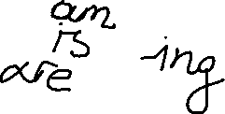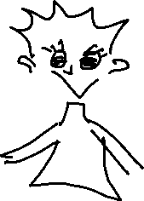

Affirmative Interrogative Negative



|  |  |  |
| --- | --- | --- |
| I am working | Am I working? | I am not working |
| You are working | Are you working? | You are not working |
| He is working | Is he working? | He is not working |
| She is working | Is she working? | She is not working |
| It is working | Is it working? | It is not working |
| We are working | Are we working? | We are not working |
| You are working | Are you working? | You are not working |
| They are working | Are they working? | They are not working |

1. 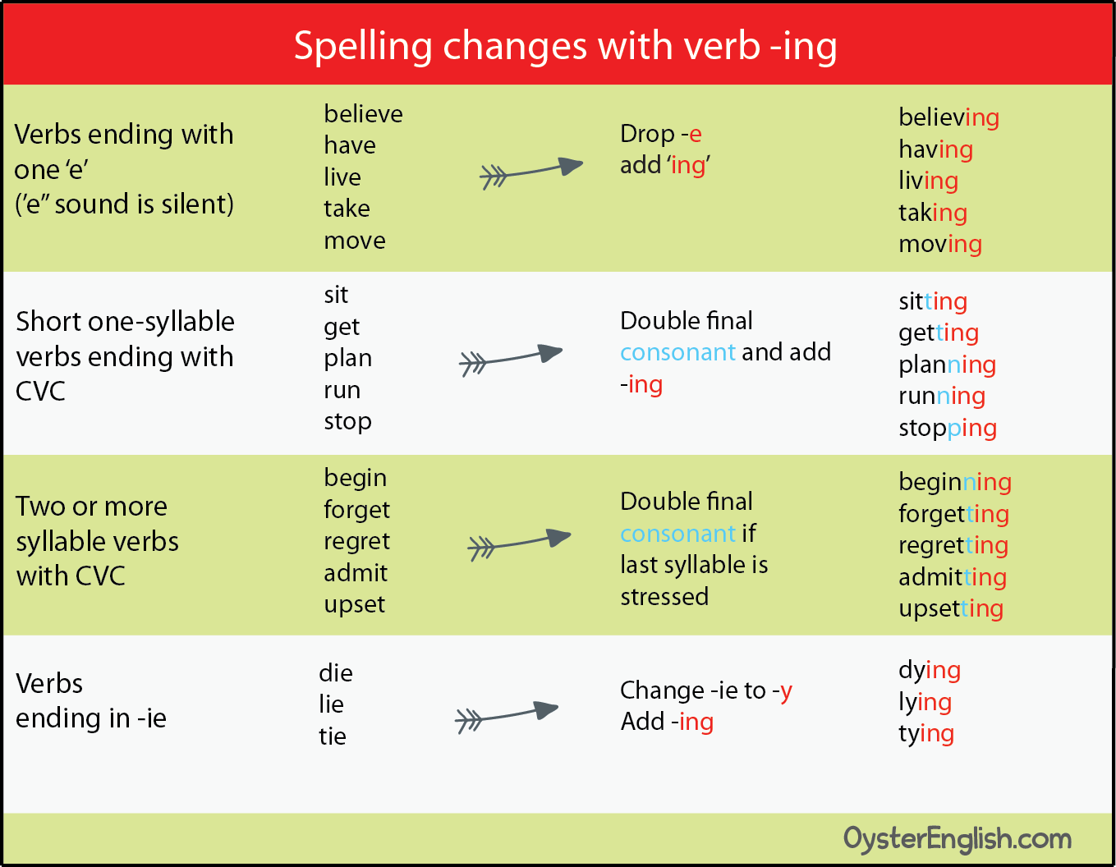
2. **“is” or “are”.**
3. **Kate _____ cooking a turkey for dinner.**
4. **Mom _____ setting the table.**
5. **John ______ making coffee.**
6. **The boys _____ watching TV.**
7. **It ____ snowing outside.**
8. **The baby ____ laughing.**
9. **The girls _____ painting Easter eggs.**
10. **We_______ eating turkey.**
11. **The dog ____ barking.**
12. **They _____ celebrating Easter.**

**C. Write the correct “ing” verb in the blank. Βάλε σωστά το “ing”**

**Short forms**

**1.Kate is ______________ dinner (prepare).**

I’m not working

you aren’t working

he isn’t working

she isn’t working

it isn’t working

we aren’t working

you aren’t working

they aren’t working

**2.They are _________ for Easter eggs (hunt).**

**3.We are ______________ turkey (eat).**

**4.The Easter Bunny is ___________ (come).**

**5.I am ____________ Easter eggs (make).**

**6.The children are ____________ candy (eat).**

**7.You are ______________ a nice song (sing).**

**8.The dog is _____________ the cat (chase).**

**9.The cat is ________________ (run).**

**10.He is _______________ coffee (drink).**

1. **Make a question. Φτιάξε τις ερωτήσεις:**

**1._______I _____________ dinner? (cook)**

I ‘m working

you’re working

she’s working

it’s working

we’re working

you’re working

they’re working

**2. _______ Jack ______________ pie? (bake)**

**3._______ the girls ______________? (eat)**

**4.___ it_______________? (rain)**

**5. ____they___________Easter eggs? (make)**

**6.______ you ____________? (coming)**

**7. ____ the dog________________? (bark)**

**8._____ she ________________? (talk)**

**9.______he ____________________? (laugh)**

**10_____Kate and John ____________? (sleep)**