C CLASS OF PRIMARY SCHOOL – UNIT 1

- Match the pictures with the correct school objects.
Rubber Ruler Pencil case

Schoolbag Sharpener Notebook

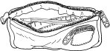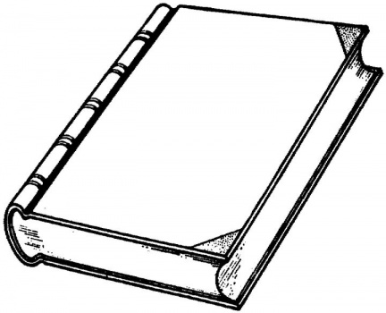
1……………………………………… 2…………………………………………………..

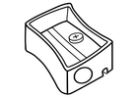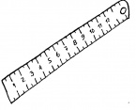
3……………………………………… 4……………………………………………………

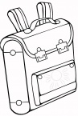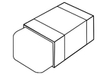
5…………………………………….. 6………………………………………………………
..../ 6

