D. Colour the picture.

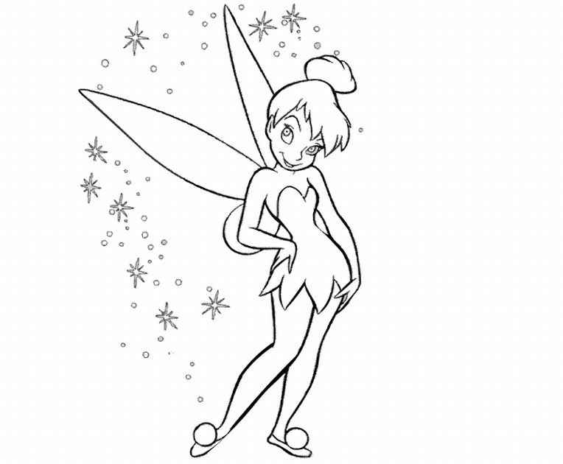
RED
GREEN
PINK
BLUE

..../ 2

