PROGRESS TEST 1 (UNITS 1-3) FOR THE 5TH CLASS OF PRIMARY SCHOOL

VOCABULARY
1. Word Categories: Put the words in the box in the correct column.
lake by boat river island quiet mountain wet busy by bus fantastic on foot by bike hill by plane sad

Geographical nouns | Adjectives | Means of transport

2. Countries and nationalities: Look at the flags and the countries. Then complete the nationalities.

- Spain  1.______________________
- Britain  2. ______________________
- Russia 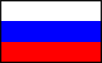 3. ______________________
- Greece  4. ______________________
- USA  5. ______________________

3. Feelings: Match the people and the way they feel. (sad, happy, bored, angry, sorry)



------------- -------------- -------------- --------------- ---------------

4. Write the following words in Greek.

- Owner =
- Hop =
- Neighbourhood =
- Suburb =
- Colleague =
- Traffic =
- Go straight =
- Headmistress =
- Invitation =
- Capital =

STRUCTURES
Adverbs of frequency.
A school survey: Good and bad habits
Look at the chart and write the results of the school survey. e.g. The pupils in my class always do their homework well.

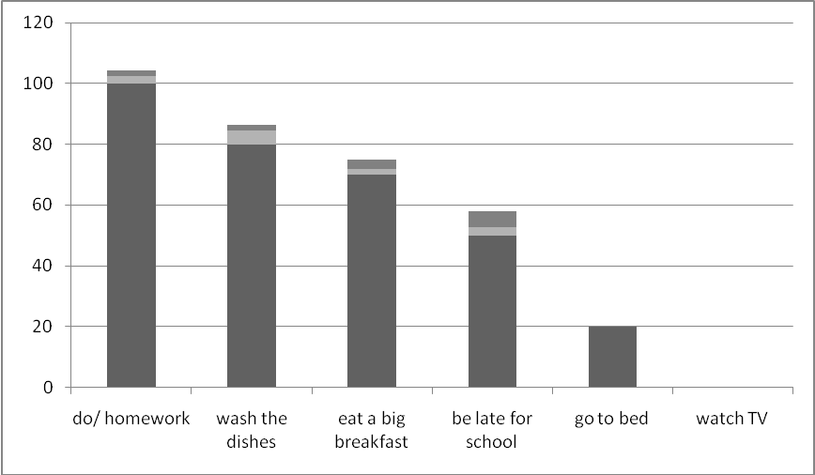

Always:100% Usually:80% Often: 70% Sometimes: 50% Rarely: 20% Never: 0%
- They ___________ ____________ the dishes.
- They ___________ ____________ a big breakfast.
- They ___________ ____________ late for school.
- They ___________ ____________ to bed late.
- They ___________ ____________ TV.

- Look at these time words and put them in the correct column with the appropriate preposition.

25th March the morning May Day January 1st Spring 4:45
Christmas Easter December two o’clock the weekend night
May summer 1998 weekdays noon Christmas Eve Thursday
AT | ON | IN

- Provide the missing questions or answers.

- How do you usually go to school? ………………………………………………
- ……………………………….? Mark’s father is a grocer.
- ……………………………….? Well, go down this street and you can see the bank on your right.
- What do you think I should buy for my father’s birthday? ………………………………………………
- How long does it take Kostas’ mother to get to work? ………………………………………………



