NAME:   
CLASS:

1. Κύκλωσε τα αγαπημένα μαθήματα των παρακάτω παιδιών από τις πληροφορίες για τα πράγματα που τους αρέσουν.

* Jim likes **numbers**. His favourite subject is Language / Maths.
* Sandra likes **playing football**. Her favourite subject is Physical Education (PE) / Religious Education (RE).
* Helen likes **trees** and **flowers**. Her favourite subject is Environmental Studies (ES) / Maths.
* Philip likes **singing** and **playing the piano**. His favourite subject is Language / Music.
* Charles likes **making pictures**. His favourite subject is Music / Art.

1. Βρες τους αριθμούς.

* Twenty-two + sixteen = …………………………………
* Ninety-one – thirty = ……………………………………
* Seventy + twenty-nine = ………………………………..
* Eleven + sixty-six = ……………………………………..
* Fifty-nine + forty-one = …………………………………

1. Βρες τη μέρα κοιτώντας το ημερολόγιο.
   * 10 August : …………………………… 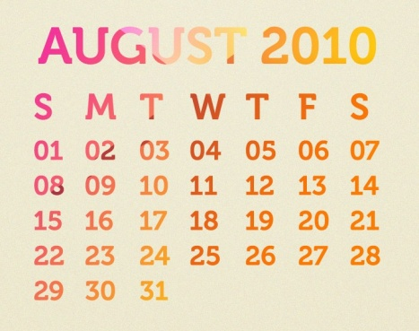
   * 26 August: ……………………………
   * 01 August: ……………………………
   * 13 August: ……………………………
   * 25 August: ……………………………

Good luck !!!