C CLASS OF PRIMARY SCHOOL
NAME : ……………………………………….

- Which of the following are healthy and which are unhealthy?

bananas, pizza, bread, chocolate, milk, fruit, ice cream, carrots, sweets, cheese

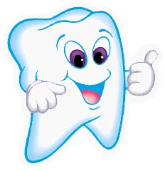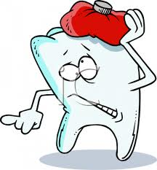

………………………………………………………………………………………………………………………………………………………………………………………………………………………………………………………………………………………………………………………………………………………………………………………………………………………………………………………………………………………………………………………………………………………………………………………………………………………………………………………………………………………………………………………………………………………………………………………………………………………………………………

- Complete the train with the days of the week.

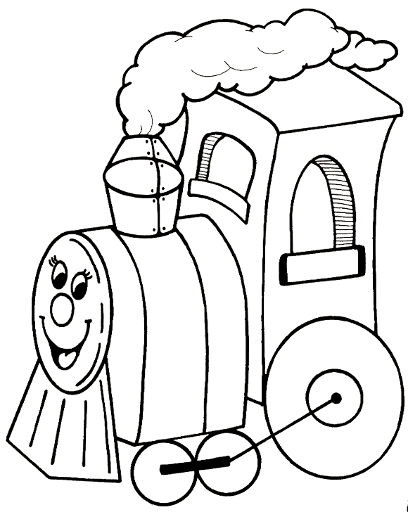

M…………………

T…………………

W…………………

T…………………

F…………………

S……………!!!

S……………!!!

