- Look at the pictures and fill in the missing words for sports.
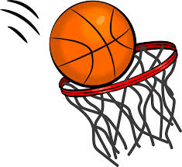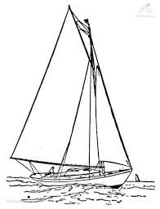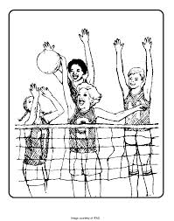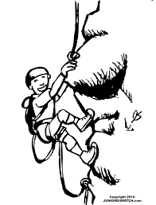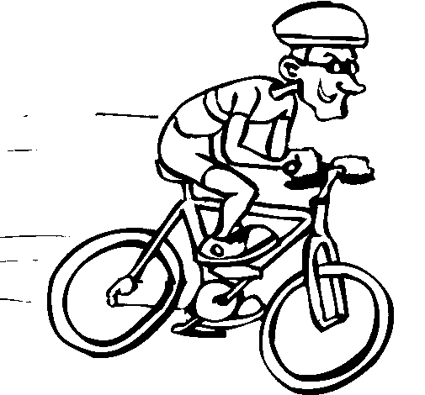
……………. ……………… ………………... …………….. ……………….

- Look at the grid and fill in with: like, don’t like, likes, doesn’t like.
Name | Singing | Listening to music | Playing computer games | Climbing | Sailing
Paul | √ | √ | X | X | X
Marry | √ | X | √ | X | √
Harry | X | X | √ | √ | X
John | √ | X | X | X | √
Sotiria | X | √ | √ | X | √
- Paul……………………....singing but Harry………………….…… it.
- Paul and Mary…………………..climbing but Harry……..……………… it.
- John, Mary and Sotiria………………..sailing but Paul ……………………it.
- Mary, Harry and Sotiria…………………playing computer games but John and Paul………………………..it.

- Match the words with their meaning.

- Athlete
- Take photos
- Collect
- Collection
- Handicraft
- Stamp
- Χειροτεχνία
- Συλλογή
- Αθλητής
- Γραμματόσημο
- Συλλέγω
- Βγάζω φωτογραφίες

Good luck!!!!

