- Match the two halves of the sentences to talk about customs in Britain.

1.At Christmas we put a. mince pies for dessert
2. At Christmas we decorate b. the presents under the Christmas tree
3. Children open c. to spooky parties on Halloween
4. At Christmas people eat d. carols on Christmas Eve
5. People go e. a tree
6. Children sing f. their presents on Christmas Day

1……… 2……… 3………. 4……….. 5…….. 6………..

- Write 4 habits you have using always, often, sometimes and never.
- I…………………………………………………………………….
- I…………………………………………………………………….
- I…………………………………………………………………….
- I…………………………………………………………………….

- Put the words in the blankets.
guy decorate eat November send
On Halloween people………………….their houses with Jack-O-Lanters.
At Christmas people ………………….cards to each other.
At Christmas people ………………….roast turkey for dinner.
Bonfire Night is on…………………….5th. Some people make a …………….., a figure made of old clothes.

- Correct the following sentences.

- We goes to work on Holy Tuesday. ……………………………………………
- He has never eggs for breakfast………………………………………………...
- She love playing basketball with her friends. …………………………………..
- We usually don’t go to school on foot. ………………………………………...

- Write down the meaning of the following words.

Chimney = ………………………………………………
Dessert = ………………………………………………..
Plate = …………………………………………………..
Riddle = …………………………………………………
Stocking = ……………………………………………….
Popular = ………………………………………………...
Fancy costumes = ……………………………………….
Pumpkin = ………………………………………………
Witch = ………………………………………………….
Spooky = …………………………………………………

- Match the pictures with the habits.
Take a bath do my homework brush my teeth clean up my room watch TV

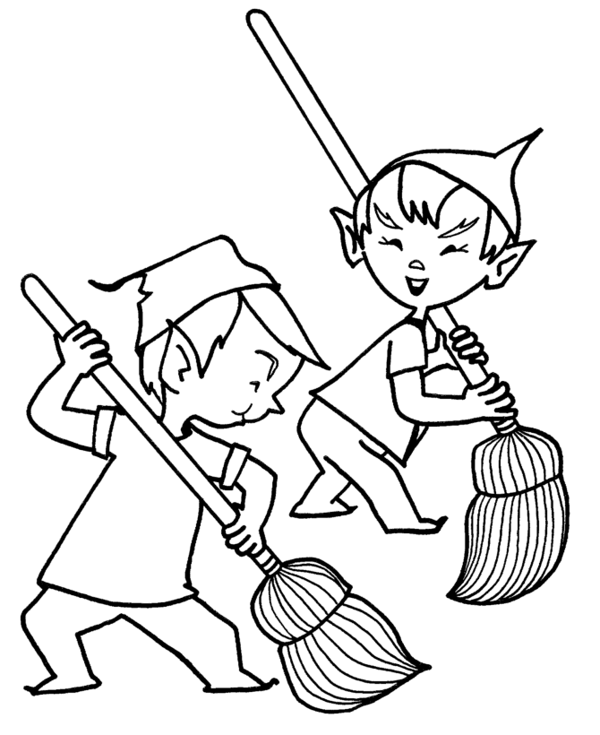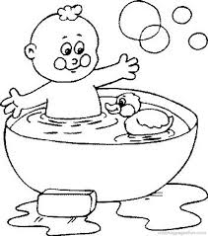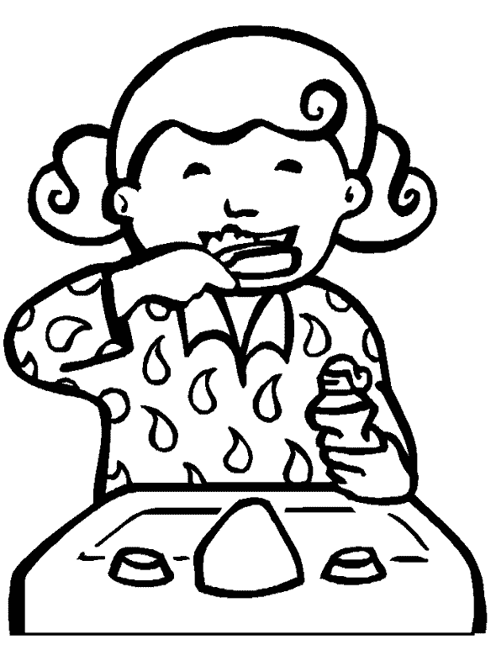
……………………….. ……………………….. …………………………

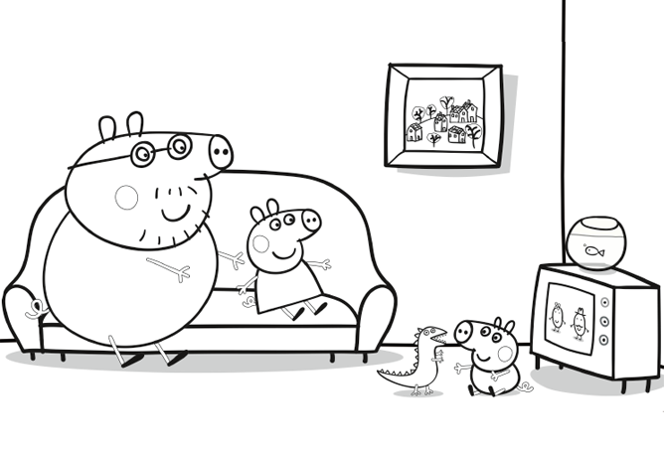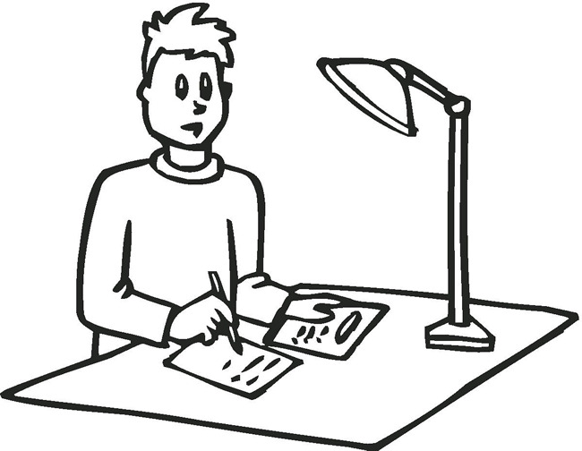
…………………………………………. ………………………………………

Good luck !!!

Name :……………………………………………………………..
Date : ……………………………………………………………...
Mark : ……………………………………………………………..

