**D CLASS OF PRIMARY SCHOOL**

**TEST --- UNIT 2**

**NAME:**

1. Αντιστοίχισε τις παρακάτω στήλες.
   * + collecting books
     + making stamps
     + collecting computer games
     + reading to the cinema
     + collecting tree leaves
     + playing models
     + taking board games
     + making to music
     + playing clothes for dolls
     + listening comics
     + going photos
     + watching football cards
     + reading TV
2. Ταίριαξε τις εικόνες με τα αθλήματα.

tae kwon do rugby hockey football baseball dancing

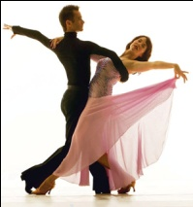

a)……………………………. b) ………………………………………..

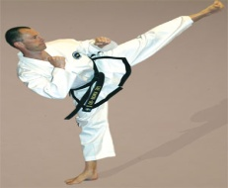 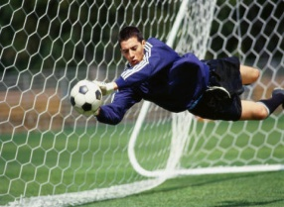

c) ……………………………. d) ………………………………………..

 

e) ………………………….. f) ……………………………………….

1. Κύκλωσε τη σωστή λέξη.
2. She likes reading. Let’s give her a **radio / comic book / bike .**
3. She likes music. She’s good at **singing / taking photos / making models.**
4. She likes playing board games. Let’s give her a **monopoly / playStation / TV.**
5. She likes dancing. Let’s give her **a ball / ballet shoes** / **a racket**.
6. She likes listening to music. Let’s give her a **camera / radio / basketball.**
7. Απάντησε στις παρακάτω ερωτήσεις για τον εαυτό σου.

* Do you like swimming?
* ………………………………………………..
* Do you like windsurfing?
* ………………………………………………..
* Do you like horse riding?
* ………………………………………………..
* Do you like climbing?
* …………………………………………………
* Do you like cycling?
* ………………………………………………….

1. Να γράψεις τη σημασία των παρακάτω λέξεων στα ελληνικά.

* Athlete =
* Racket =
* Sailing =
* Sporty =
* Clothes =
* Collection =
* Handicraft =
* Leaf – leaves =
* Stamp =
* Sleeping =

1. Να κλίνεις το ρήμα **Like** σε *κατάφαση, ερώτηση και άρνηση*.