PROGRESS TEST 1 (UNITS1-3) FOR THE 4TH CLASS OF PRIMARY SCHOOL

NAME : GRADE:

1. Write the numbers. Use words.

* 42 + 26 = …………………………………………..
* 13 + 11 = …………………………………………..
* 82 – 43 =……………………………………………
* 99 – 22 = …………………………………………...
* 23 + 25 =……………………………………………
* 50 + 50 = ……………………………………………
* 12 + 59 = ……………………………………………
* 67 – 33 = ……………………………………………
* 90 – 20 = ……………………………………………
* 36 + 27 = ……………………………………………

1. Look at the timetable for Monday and complete the sentences with have got, has got, haven’t got or hasn’t got.

|  |  |  |
| --- | --- | --- |
| MONDAY | | |
| **Ioanna** | **Marios** | **Stelios** |
| Language | Maths | Language |
| Language | Language | Maths |
| History | P.E. | Music |
| Music | Art | R.E. |
| School life | English | History |
| English | Environmental studies | Art |

On Monday…

* Stelios and Marios ………………………..School life.
* Stelios …………………………..R.E.
* Marios and Stelios ………………………..Maths and Art.
* Marios …………………………History.
* Ioanna ………………………….English.

1. Look at the pictures and fill in the missing words.

 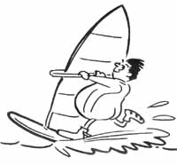

…………………………….. ……………………………….

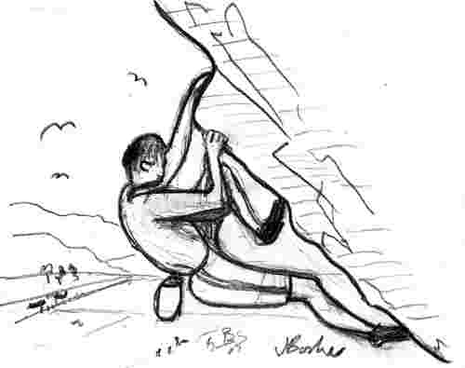 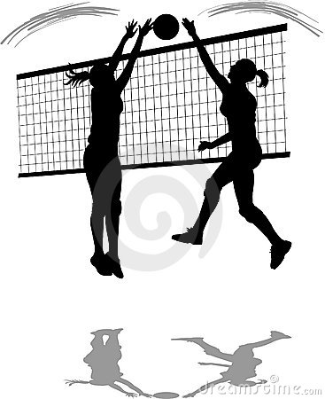

………………………… ………………………………..

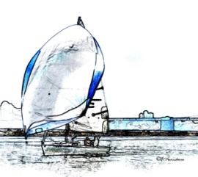

…........................................

1. Look at the grid and fill in the missing words in the blanks. Use **likes** / **doesn’t** **like**, **like / don’t like**.

|  |  |  |  |  |  |
| --- | --- | --- | --- | --- | --- |
| **Name** | singing | listening to music | playing computer games | climbing | sailing |
| Paul | √ | √ | **×** | **×** | **×** |
| Mary | √ | **×** | √ | **×** | √ |
| Harry | **×** | **×** | √ | √ | **×** |
| John | √ | **×** | **×** | **×** | √ |
| Sotiria | **×** | √ | √ | **×** | √ |

* Paul…………….singing but Harry ……………… it.
* Paul and Mary ………………climbing but Harry ………………it.
* John, Mary and Sotiria………………..sailing but Paul…………………..it.
* Mary, Harry and Sotiria………………….playing computer games but John and Paul……………………….it.

1. Where are these children from? Fill in the missing words.

* Hi! I’m Mark and I’m from the **United Kingdom**. I’m ________________.
* Hi! I’m Sylvana and I’m from **Italy**. I’m ____________________.
* Hi! I’m Spyros and I’m from **Greece**. I’m ___________________.
* Hi! I’m Kahi and I’m from **Albania**. I’m ____________________.

1. Look at the pictures and fill in the words. Choose from the list.

***museum, church, post office, block of flats, shopping centre***

 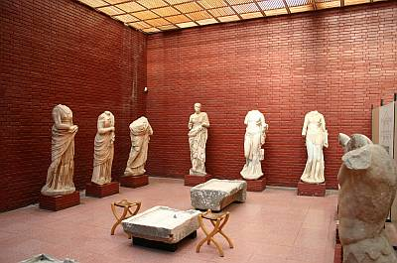 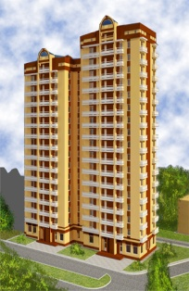

………………………….. ………………………….. …………………….

 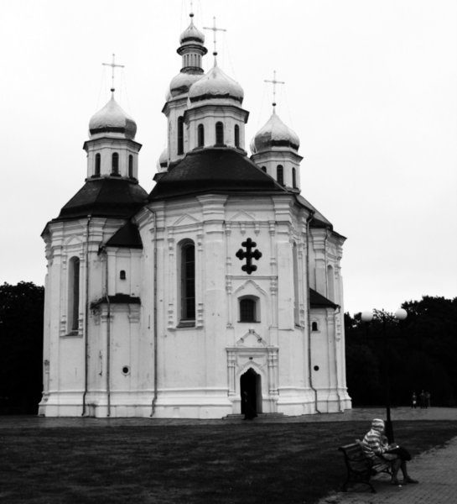

……………………….. ……………………………………

1. Write the meaning of the following words in Greek.

* Headteacher =
* Map =
* Collection =
* Handicraft =
* Capital =
* Village =
* Between =
* On the corner of =
* Leaf – leaves =
* Mountain =

